EDUHELP

Web programming class project, academic year 2024 /2025

| Student Name in English | Student Name in Arabic | Student ID | Section time as shown in zajel | Work percentage |
| --- | --- | --- | --- | --- |
| Shahd Almasri | شهد المصري | 12112962 | 8-9:30 | 50% |
| Samia Asmar | ساميه اسمر | 12113993 | 8-9:30 | 50% |
|  |  |  |  |  |

8/1/2025 / 8 pm

---------------------------------------------This section is intended for the Instructor---------------------------------------

| **Topic** | **Mark** |
| --- | --- |
| Project Idea |  |
| Project Complexity |  |
| Project Tools |  |
| Project Requirements and Modeling |  |
| Project Discussion |  |
| Project Completeness |  |
| Project Output Results or reporting |  |
| Project Administration and Management |  |
| Project Report |  |
| Team work |  |
|  |  |
|  |  |
|  |  |
|  |  |
|  |  |

| Tabel of content | Number of page |
| --- | --- |
| Abstract | 2 |
| Introduction | 3 |
| Project requirement | 4 , 5 |
| Tools | 6 |
| Project Database UML | 6 , 7 |
| Discussion |  |
| Conclusion |  |
| References |  |

Abstract:

This platform aims to provide tools as well as opportunities for North American students so that they can work together and improve their learning process. It contains a unique slide-sharing system where students can upload, lend out, or search for lecture slides organized by university, course, and discipline. A robust Q&A enables users to post a question, discuss a theme, and together rank the most appropriate answers to the question. Besides the above, there is a large programming center where students can get everything necessary to learn languages like JavaScript, Java, or Python. The tool is sufficiently intuitive with its clean look and features, which allow easy access to information, collaboration, and motivation among students to reach academic success.

Introduction:

In today’s rapidly evolving educational landscape, students face increasing challenges in managing their learning materials, collaborating with peers, and mastering essential skills such as programming. To address these challenges, we propose a web platform designed specifically to meet the needs of students by providing a comprehensive and user-friendly environment for academic support. This platform acts as a centralized hub, integrating key features that enhance the student learning experience, foster collaboration, and promote self-driven education.

The platform focuses on three primary features: a Slide Sharing System, a Question and Answer Section, and a Programming Languages Learning Hub. The Slide Sharing System allows students to upload, borrow, and download lecture slides organized by university, field of study, and subject, making it easier to access the resources needed for studying. The Q&A section serves as an interactive space where students can post academic-related questions, offer answers, and engage with their peers by voting on the most helpful responses. Finally, the Programming Languages Learning Hub aims to help students learn essential programming languages such as Python, JavaScript, and Java, offering tutorials, articles, and projects that allow for practical and self-paced learning.

This platform is designed to support the dynamic academic needs of today’s students. By facilitating easy access to materials, encouraging collaboration through knowledge sharing, and providing a dedicated space for learning programming, it creates a more engaging and efficient learning environment. The goal is to empower students to take control of their academic journey, improve their skills, and collaborate more effectively with their peers. Whether it’s through accessing lecture slides, solving academic queries, or mastering programming languages, this platform is designed to enhance the overall student experience and contribute to their academic success.

Requirements :

The platform begins with a robust Sign-Up Page, where users can create accounts by entering essential details such as First Name, Last Name, Email, Password and Password Confirmation. Upon successful registration, the user's data is securely stored in the database, ensuring easy access for future logins. Subsequently, users can authenticate their accounts via the Login Page, which allows seamless access to the platform's features.

**Slide Borrowing and Post Interaction:**

For the purpose of sharing and borrowing resources related to the graduation project, a dedicated Slide Borrowing Page enables users to publish posts that include text content and attachments (e.g., slides, documents). The system maintains a specialized Posts Table, to store information about each post, including:

- **ID** (unique identifier),

- **Text Content** (description of the post),

- **File Path** (link to the attached resource),

- **Time of Publication** (timestamp),

- **Publisher's Email** (email of the user who made the post).

Additionally, users can engage with these posts by leaving comments. These comments are stored in a Comments Table , which includes:

- **ID** (unique identifier),

- **Comment Content** (text of the comment),

- **Image Path** (if an image is included with the comment),

- **Time of Comment Publication** (timestamp),

- **Post ID** (linking to the post being commented on),

- **Comment Publisher's Email** (email of the user who posted the comment).

Both tables are interlinked through the Post ID, ensuring the system can track comments accurately for each post.

**Material Inquiries and Answers:**

The platform also features a Material Inquiry Page, designed to allow users to publish academic questions and receive corresponding answers. These questions are stored in a specialized Questions Table, which includes:

- **ID** (unique identifier),

- **Question Content** (the text of the inquiry),

- **Time of Publication** (timestamp),

- **Publisher's Email** (email of the user who posted the question),

- **Answer Type** (a classification of the expected answer, such as multiple choice or free text),

- **Options** (in case of multiple-choice or checkbox answers).

When users submit answers to questions, these are stored in a dedicated

Answers Table that contains:

- **ID** (unique identifier),

- **Answer Content** (the actual response),

- **Answer Time** (timestamp of the response),

- **File Path** (if the answer includes an attachment),

- **Respondent's Email** (email of the person answering the question),

- **Question ID** (linking to the related question),

- **Selected Answer** (for multiple-choice or checkbox answer types, which indicates the option selected).

The connection between the Questions Table and Answers Table is maintained via the Question ID ensuring that each answer is properly linked to its respective inquiry.

This system architecture ensures that the platform is highly organized and efficient, with each feature seamlessly integrated into a structured database. By linking tables and utilizing unique identifiers, the system allows for smooth data retrieval and interaction across various pages, from user registration to post interactions and question answering.

Tools used in the project

1- PhpStorm, Vscode

2- Xampp

Project database EER or UML

Borrow_Post :

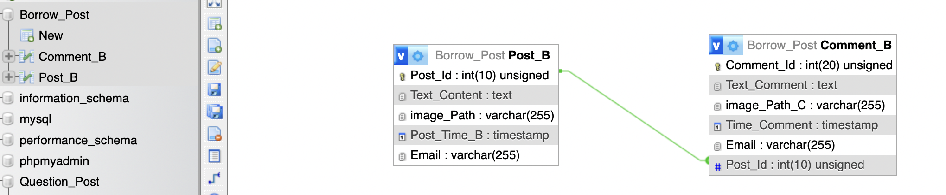

Question_Post:

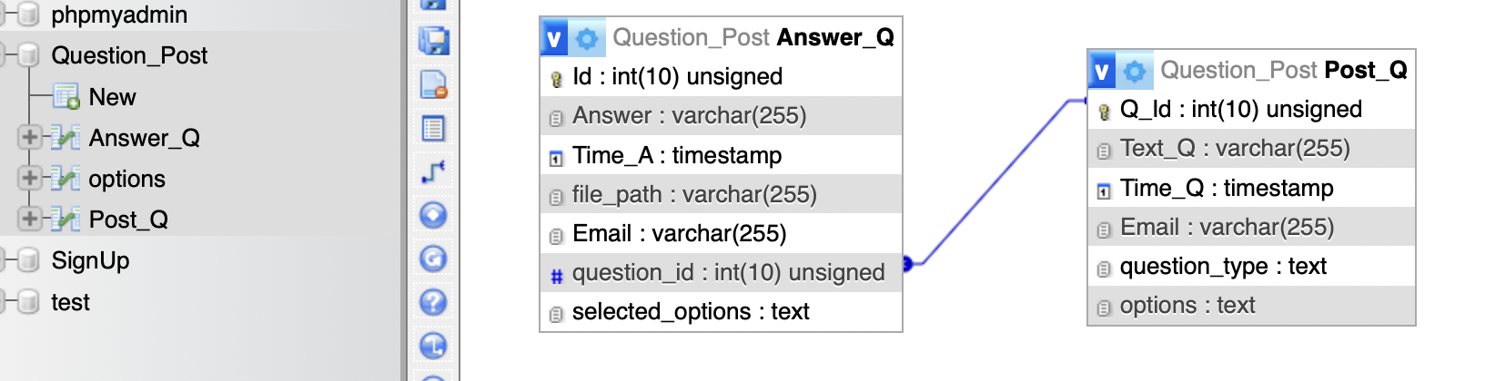

User_Info:

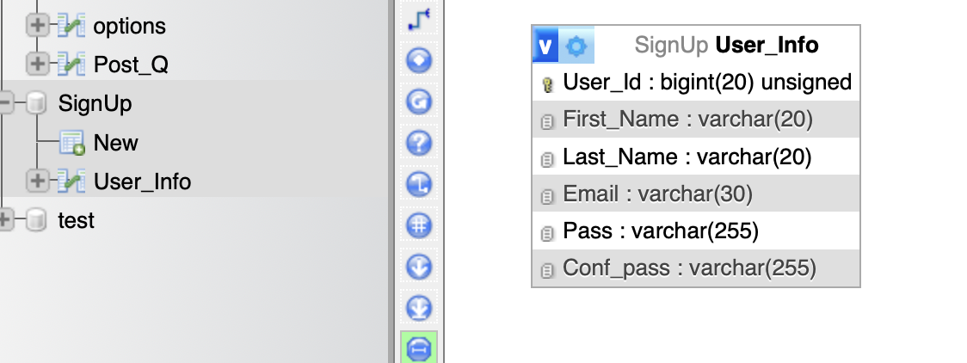

Discussion about your project GUI work, what each interface do

**Homepage Overview:**

The Home Page serves as the welcoming gateway to our platform, designed with a clear structure and user-friendly navigation, guiding visitors effortlessly through everything we offer. The layout consists of several dynamic sections, each serving a unique purpose to enhance the user experience.

**Section 1: About Us and Introduction**

The first section provides a warm welcome to visitors, offering a concise yet informative Introduction to the platform. Here, users will discover the core purpose of the site and a brief overview of the services we provide, setting the tone for a deeper exploration of what we offer.

**Section 2: Our Services**

In the second section, we showcase the Services available on the platform, each accompanied by a simple explanation to help visitors easily understand how they can benefit. This area highlights the key features of our platform, from resource sharing to material inquiries, offering visitors a clear picture of how they can make the most of their experience with us.

**Section 3: Contact Us**

The third section is dedicated to Communication, offering users a space to reach out with any feedback, questions, or concerns. Whether it’s reporting an issue, sharing a suggestion, or providing praise, users can easily send us an emailthrough this section, ensuring their voices are heard and valued.

**Navigation**

To facilitate smooth access to different parts of the site, the Navigation Bar includes a prominent Login Button. Clicking this button directs users to the Registration Page, where they can create or access their accounts, granting them full access to all the features the platform has to offer.

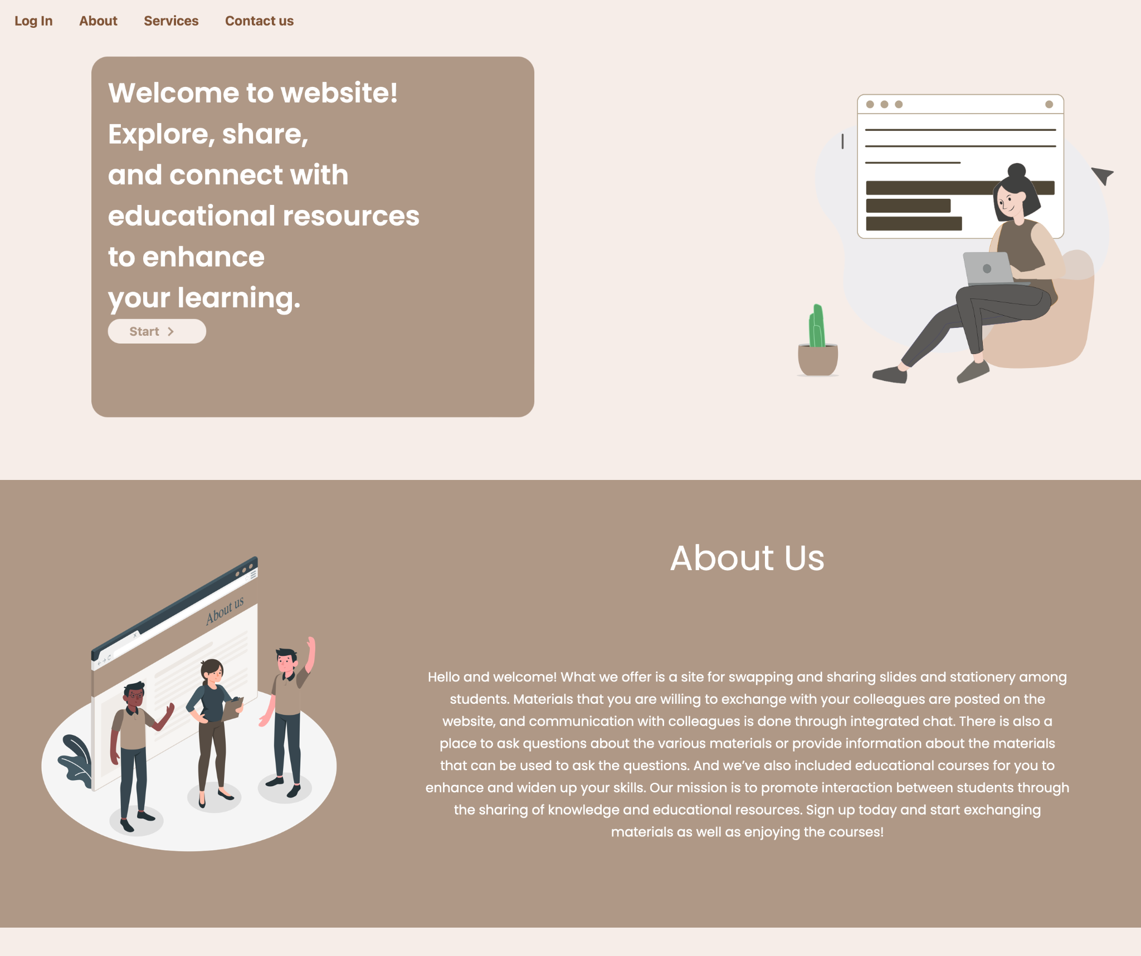

-If we click on the login or start button, it will take us to the login page.

-If we click on the about button, it will take us to the about section, the same thing for services and contact us button.

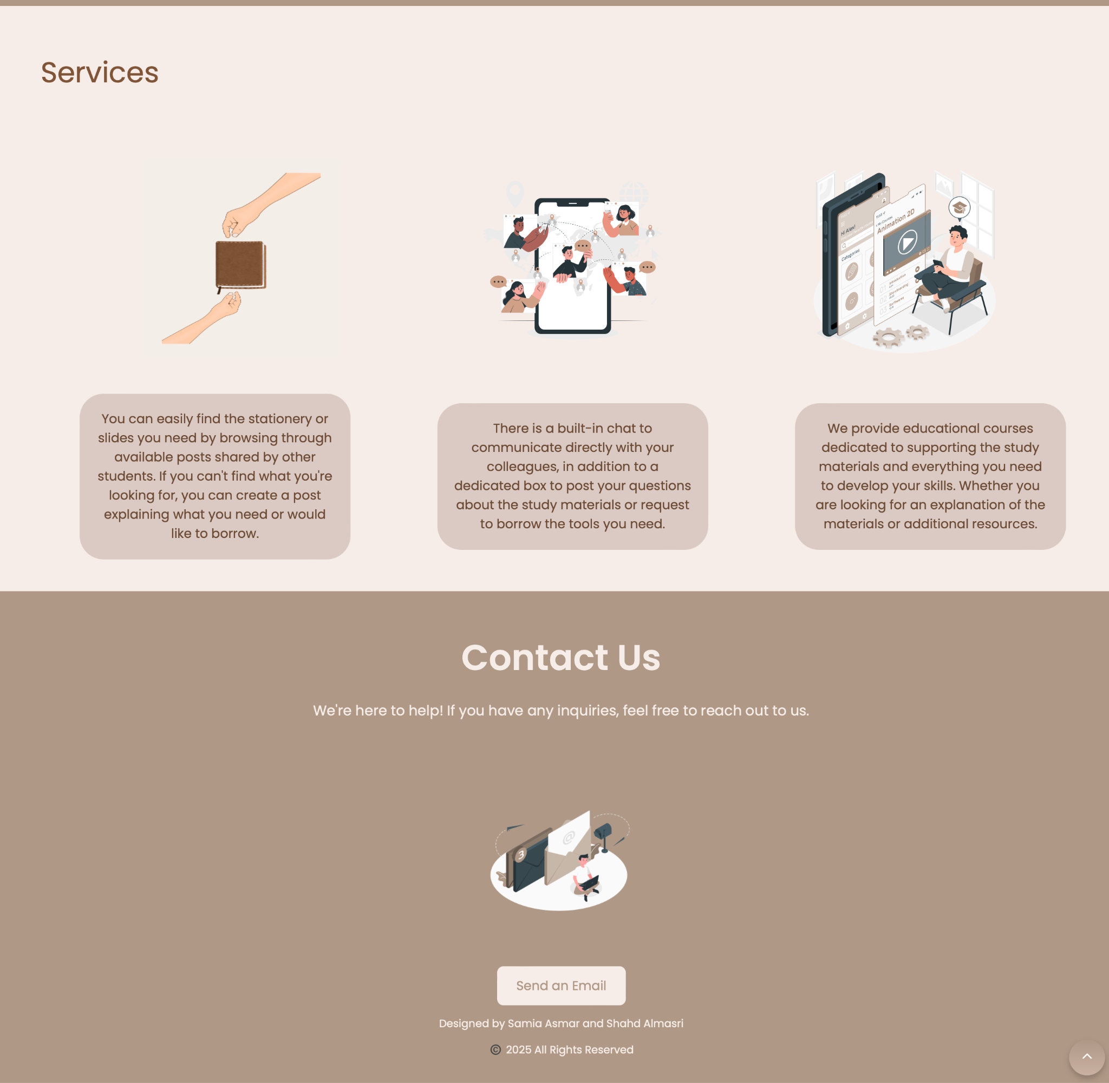

-In the Contact Us section, there is a Send On Email button. When you click on it, an email window will appear. All you have to do is send us what you need, as the admin’s emails are there.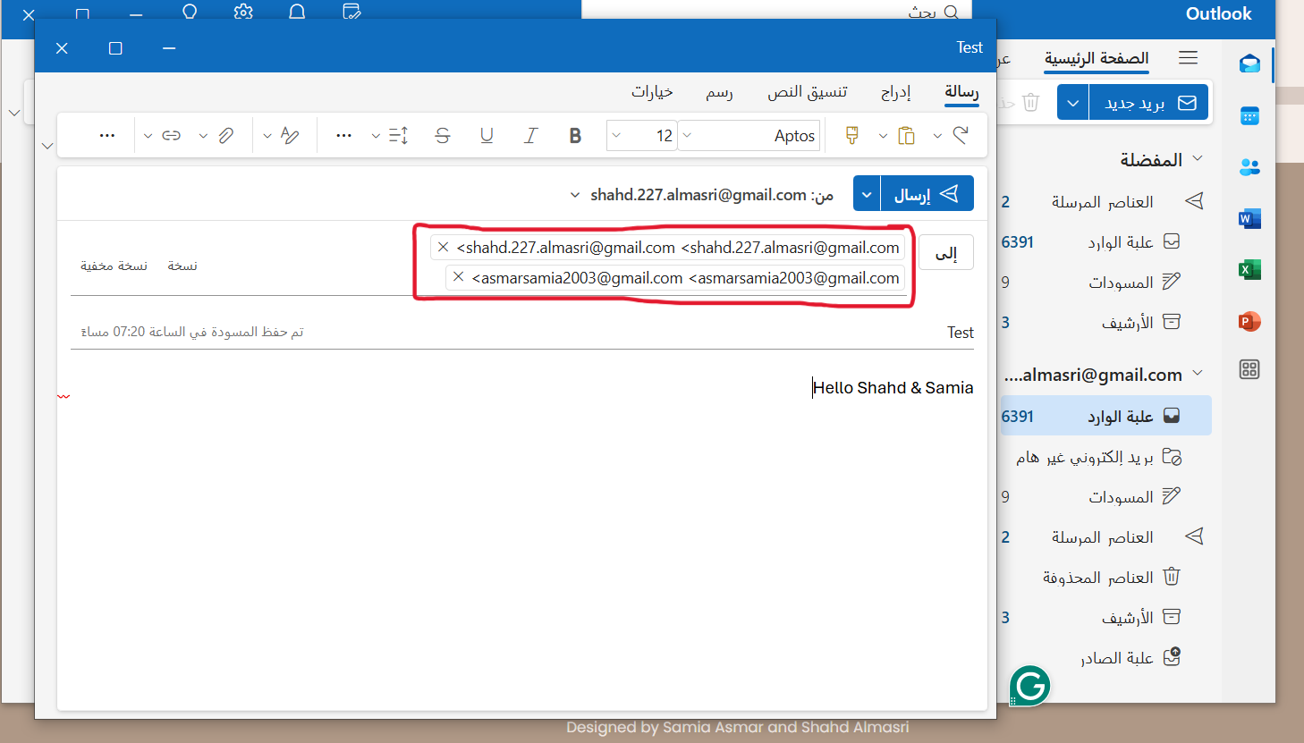

### 

### The result:

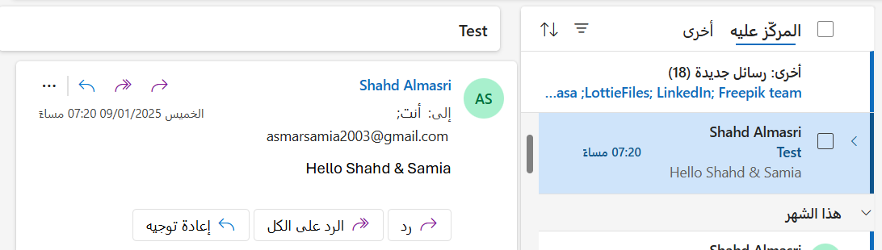

### This arrow, when clicked, takes you back to the beginning of the page.

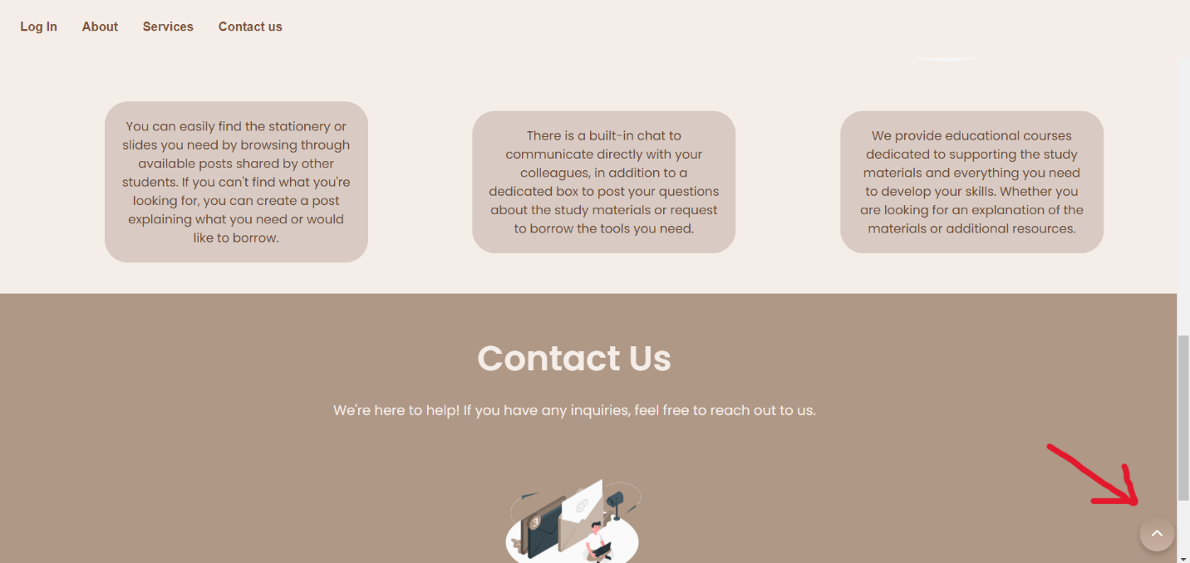

### Account Creation and Login Page

Welcome to the gateway of your personalized experience on our platform. This page is dedicated to helping you **create an account** and easily access all the features we offer.

#### Sign-Up Process

For first-time visitors, the **Sign-Up Page** is your starting point. Here, you will be asked to enter your basic information, including:

* **First Name**
* **Last Name**
* **Email**
* **Password**

By completing this simple process, you’ll create your account, and your data will be securely stored in our system, allowing you to easily return at any time.

#### Login Process

For subsequent visits, logging into your account is just as simple. All you need to do is navigate to the **Login Page**, where you will be prompted to enter:

* **Email**
* **Password**

With just a few clicks, you’ll regain access to your account and continue where you left off, making your experience seamless and hassle-free.

-On the first page, when you press the Login or Start button, this page appears.

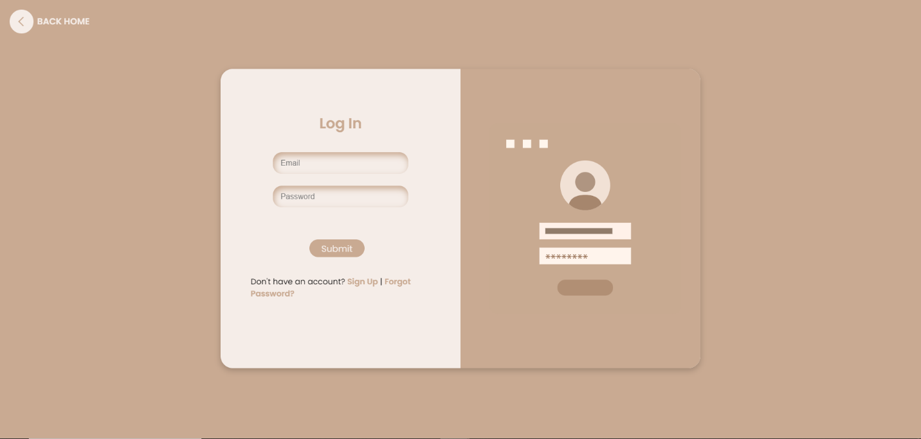

At first, you are a new user and you have to create a new account. You can create an account by clicking on the Sign Up button.

And this is the page

Signup:

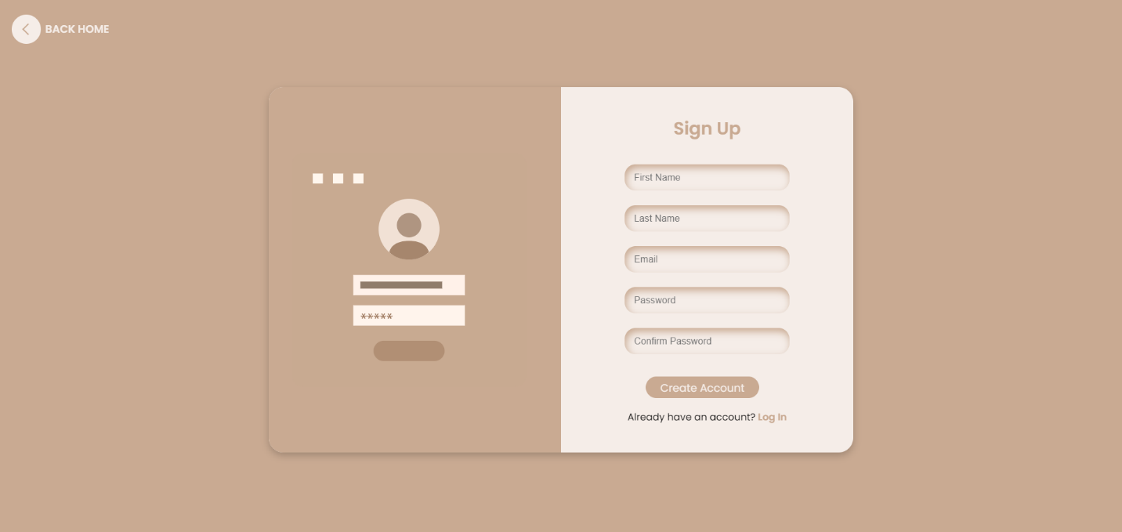

These are the accounts we have. I will make an example to add a new user.

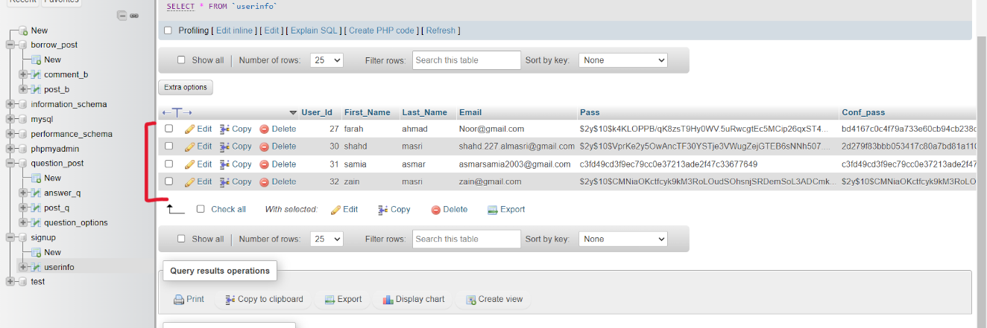

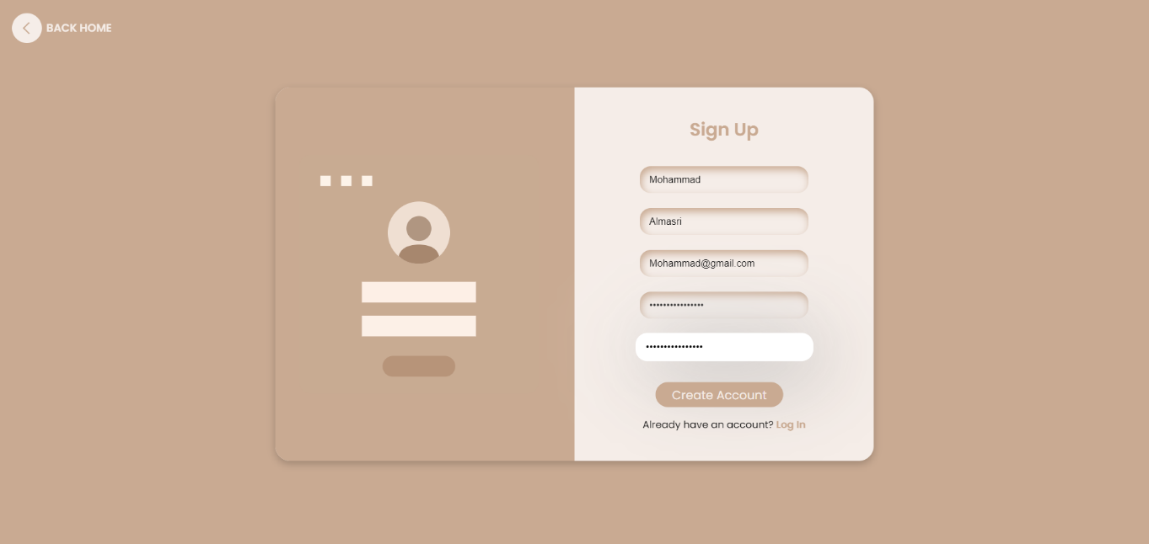

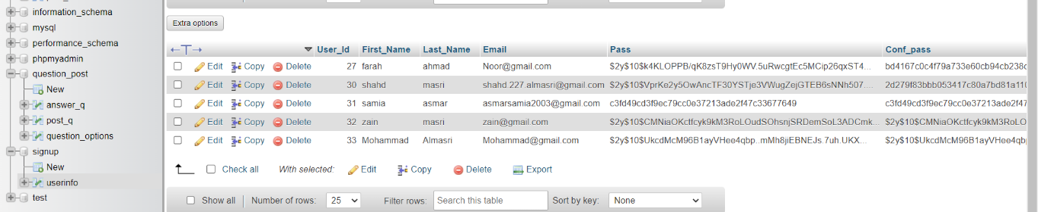



When you type your password, you must follow a certain pattern.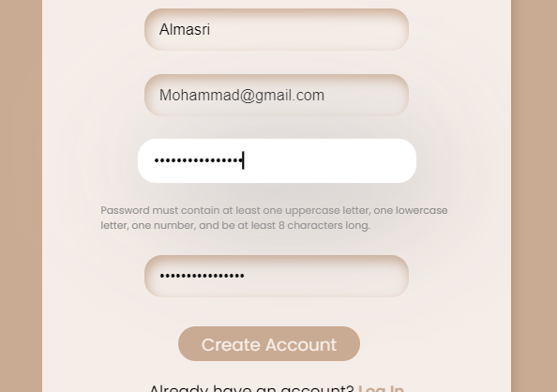

When you enter a new account and use an existing email, it does not allow you and asks you to change the email

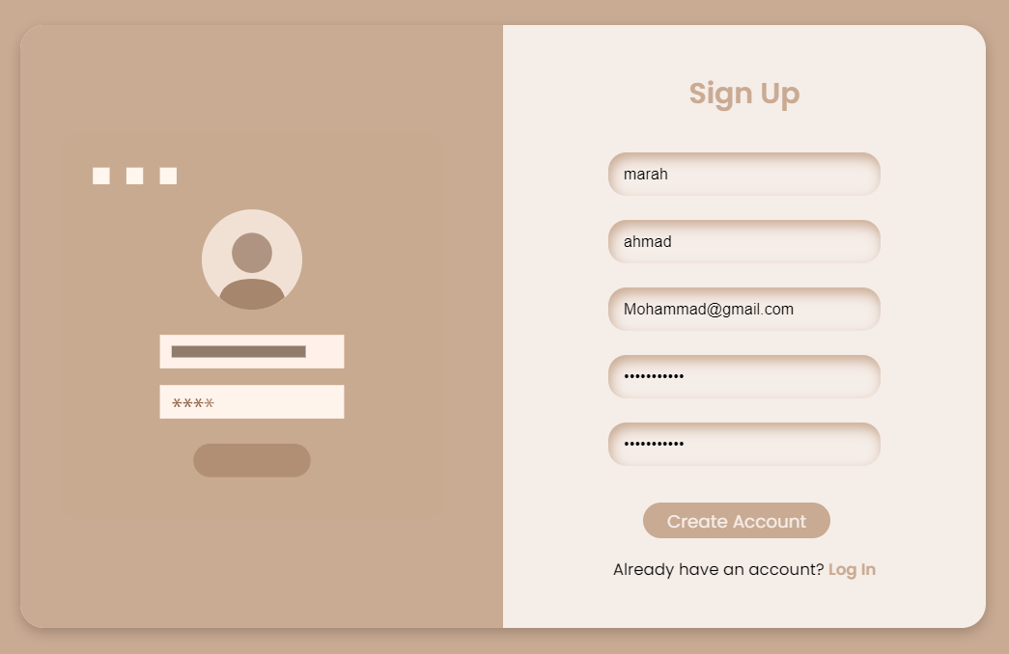

Then click on create account the result

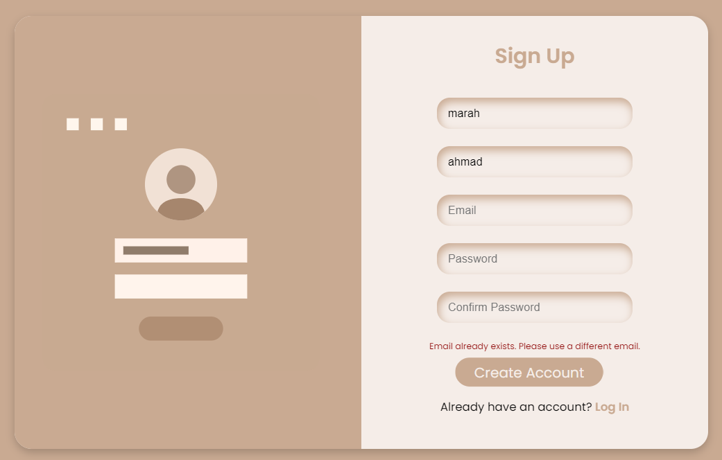

This message appears and empties the email, password and confirmation to re-enter them.

If we enter the password and confirm password are not the same, a matching message will appear.

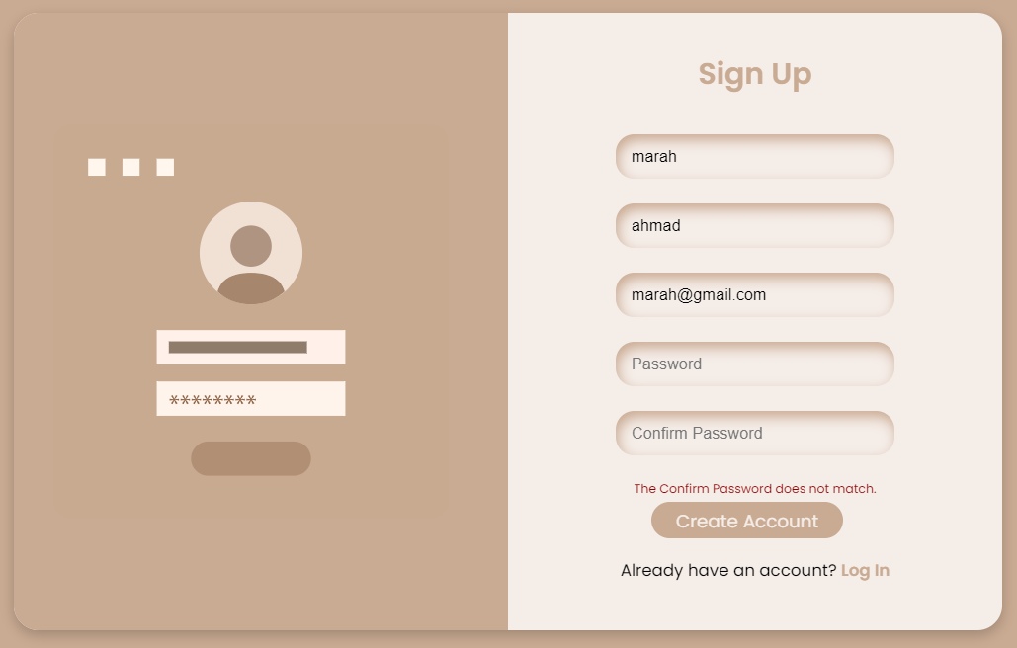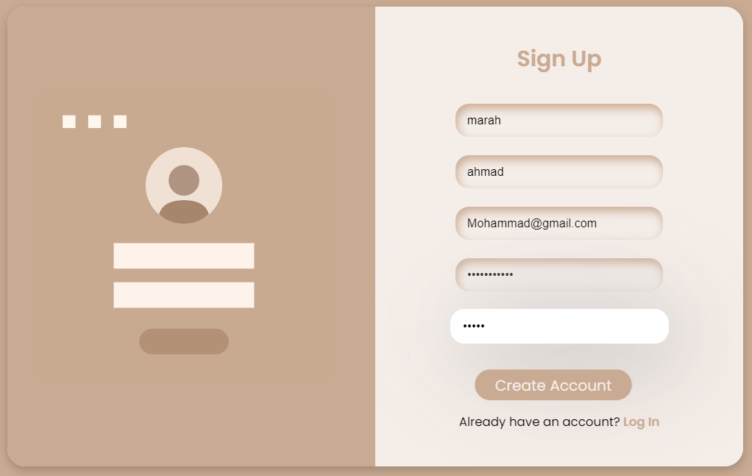



If you want to go to the login page, you can click on the login button.

LOGIN:

If you already have an account, you can log in from the login page by entering the email and password and making sure that they are correct. If they are incorrect, this message will appear.

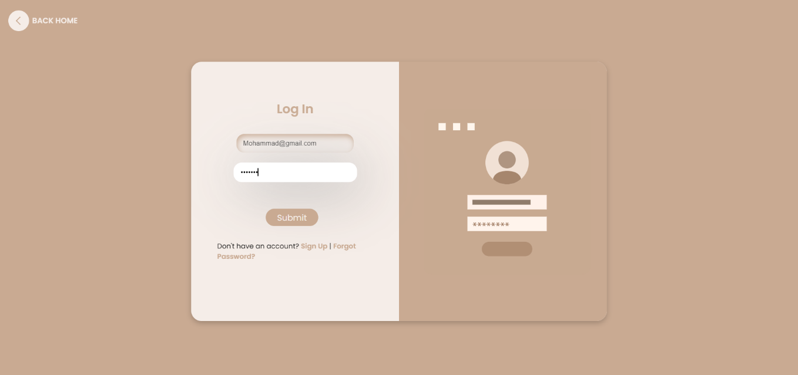



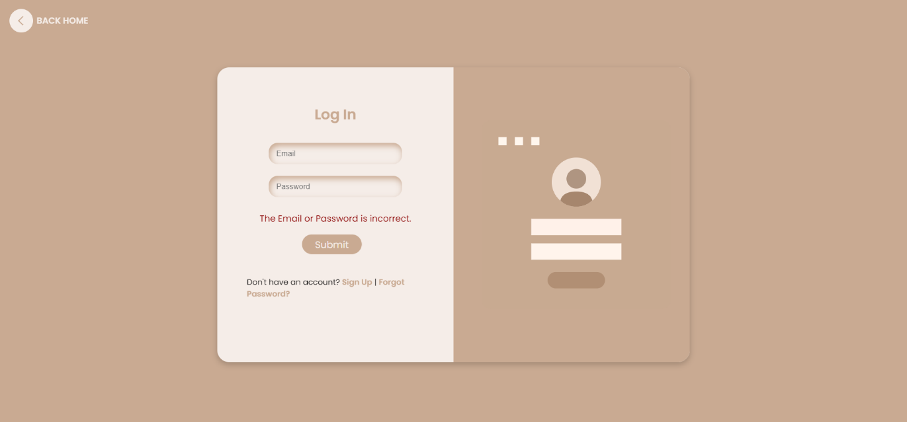

If you have an account and forgot your password, you can renew your password by clicking on Forgot Password and this screen will appear.

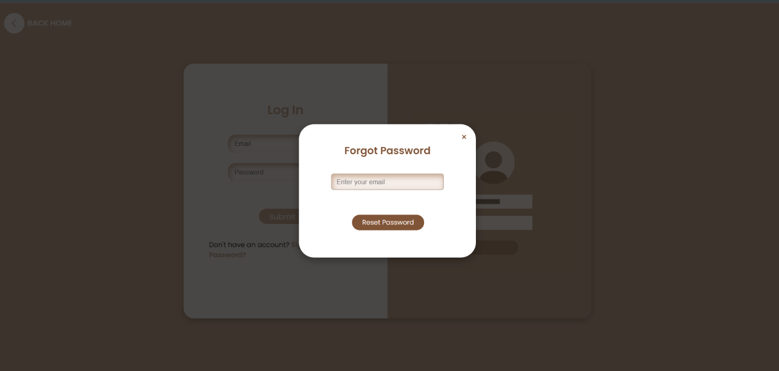

Enter your email

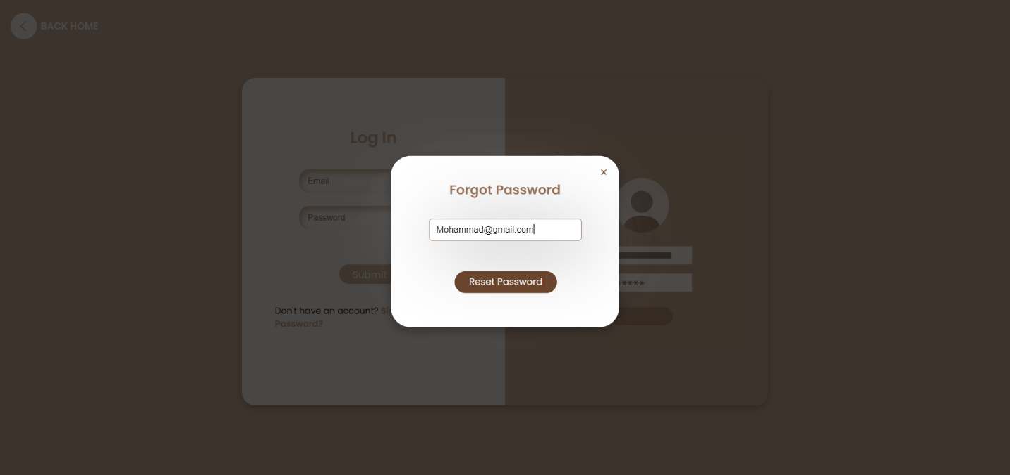

The click on Reset Password

Enter the new password within the required pattern.

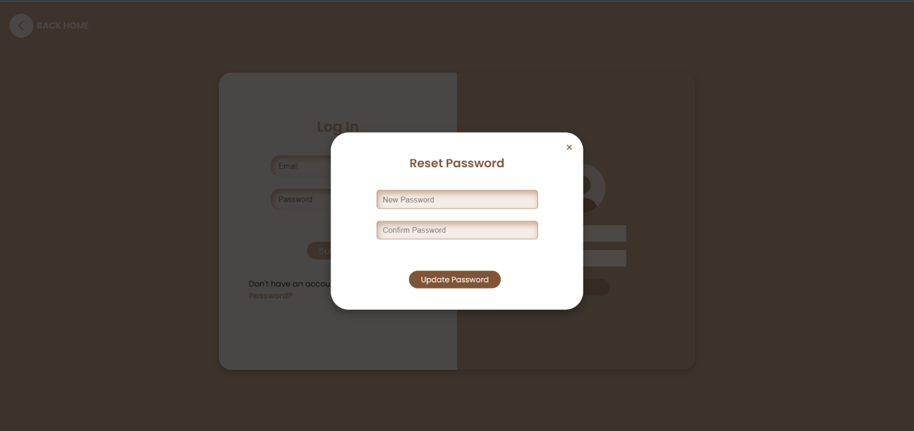

After you enter it, it will show you that.

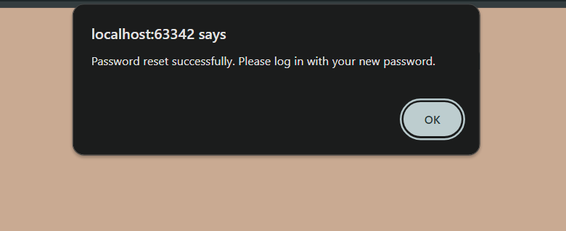

If the password and confirmation do not match, this message will appear.

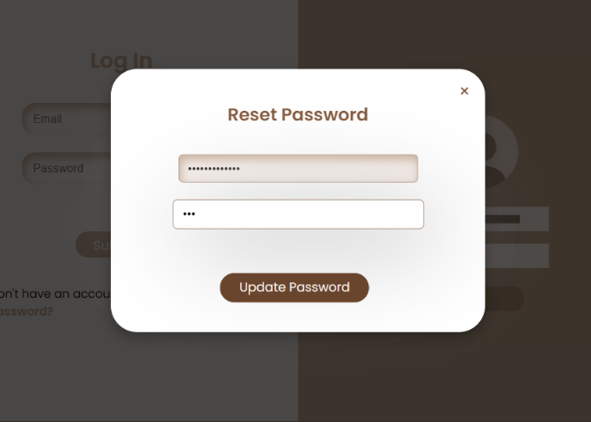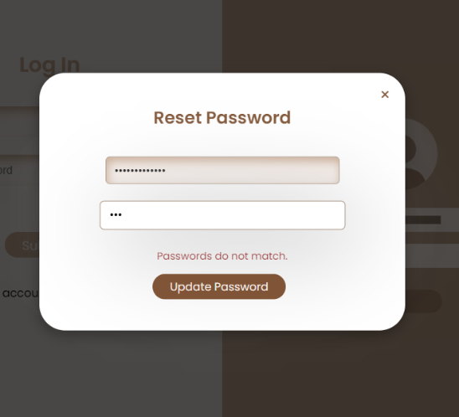



Clicking on the back home button will take you back to the home page.

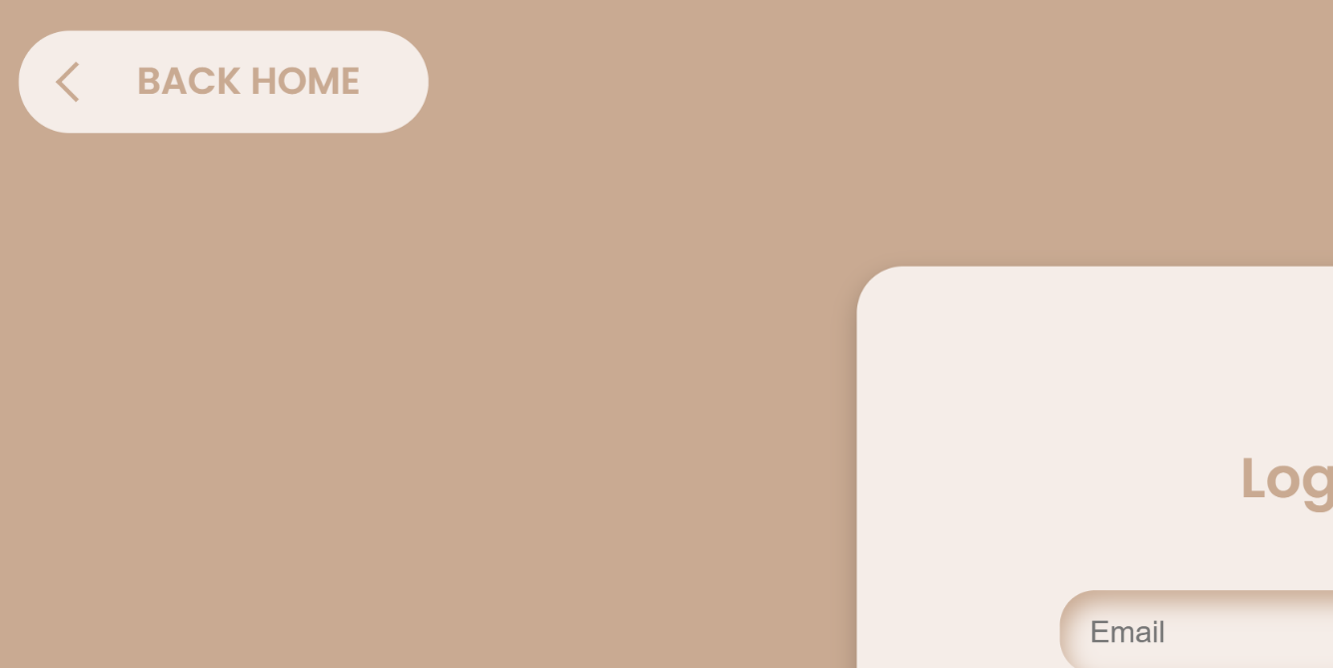

After creating an account and clicking on Create Account or after logging in and clicking on Submit, we will go to the pages page, from which we choose the page we want to go to

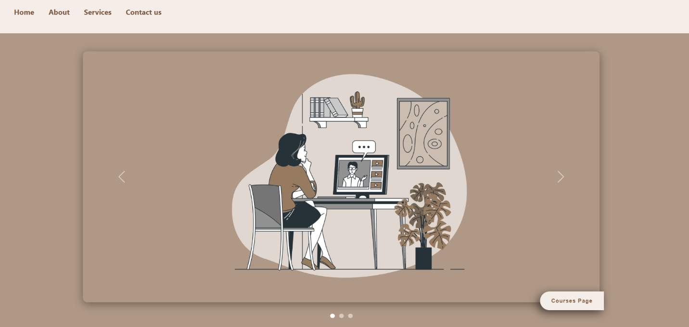

If we click on the course page, we will be transferred to the courses page.

When you click the > button

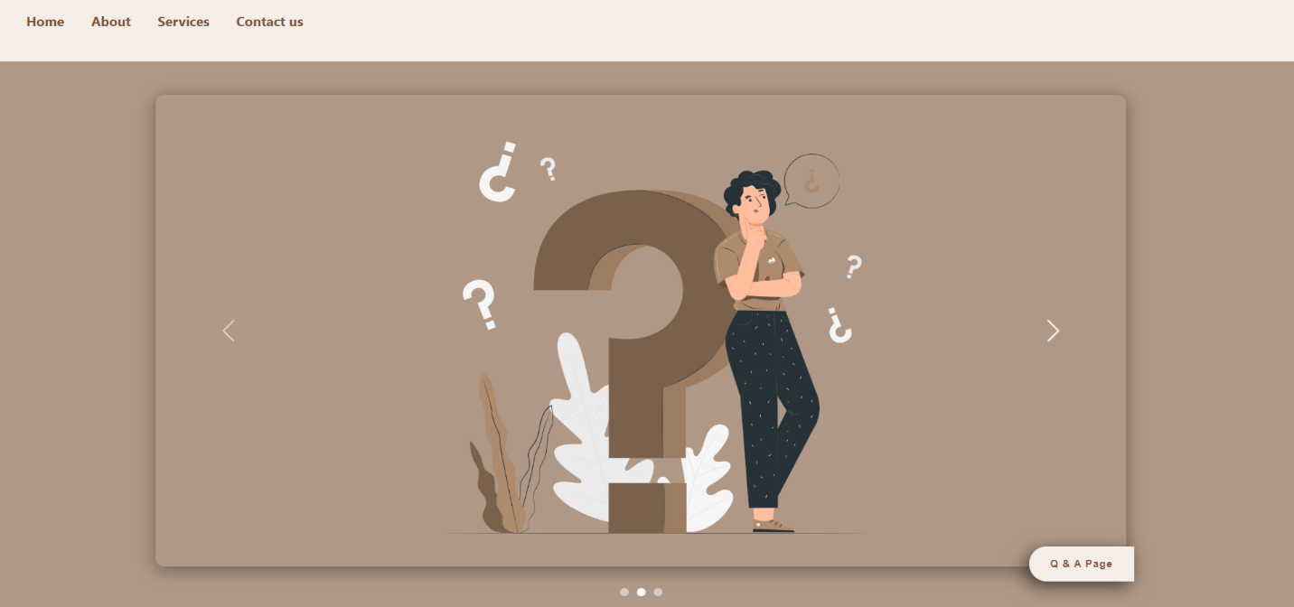

If we click on the Q & A Page, we will be transferred to the question page.

When you click the > button

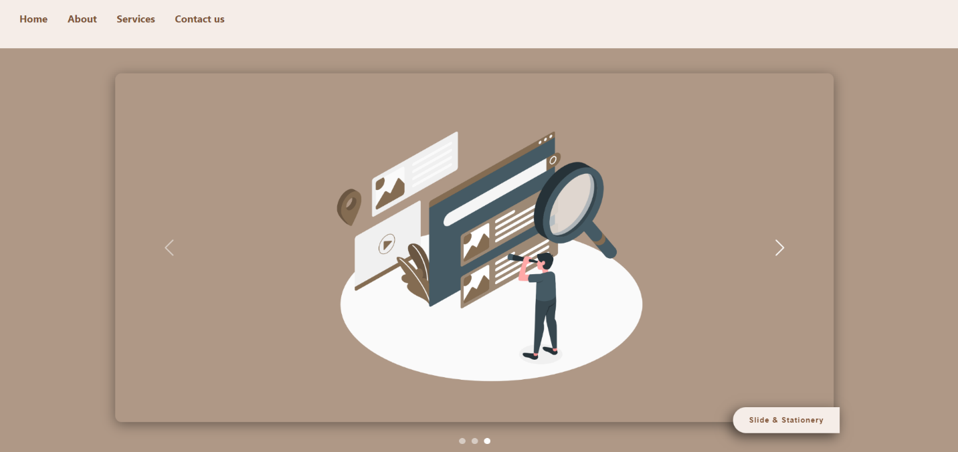

If we click on the Slide & Stationary, we will be transferred to the borrow page.

----------------------------------------------------------------------------------------------------

courses page:

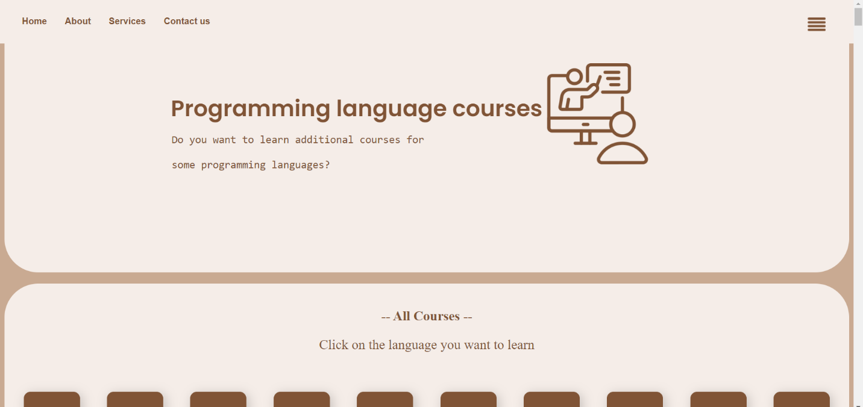

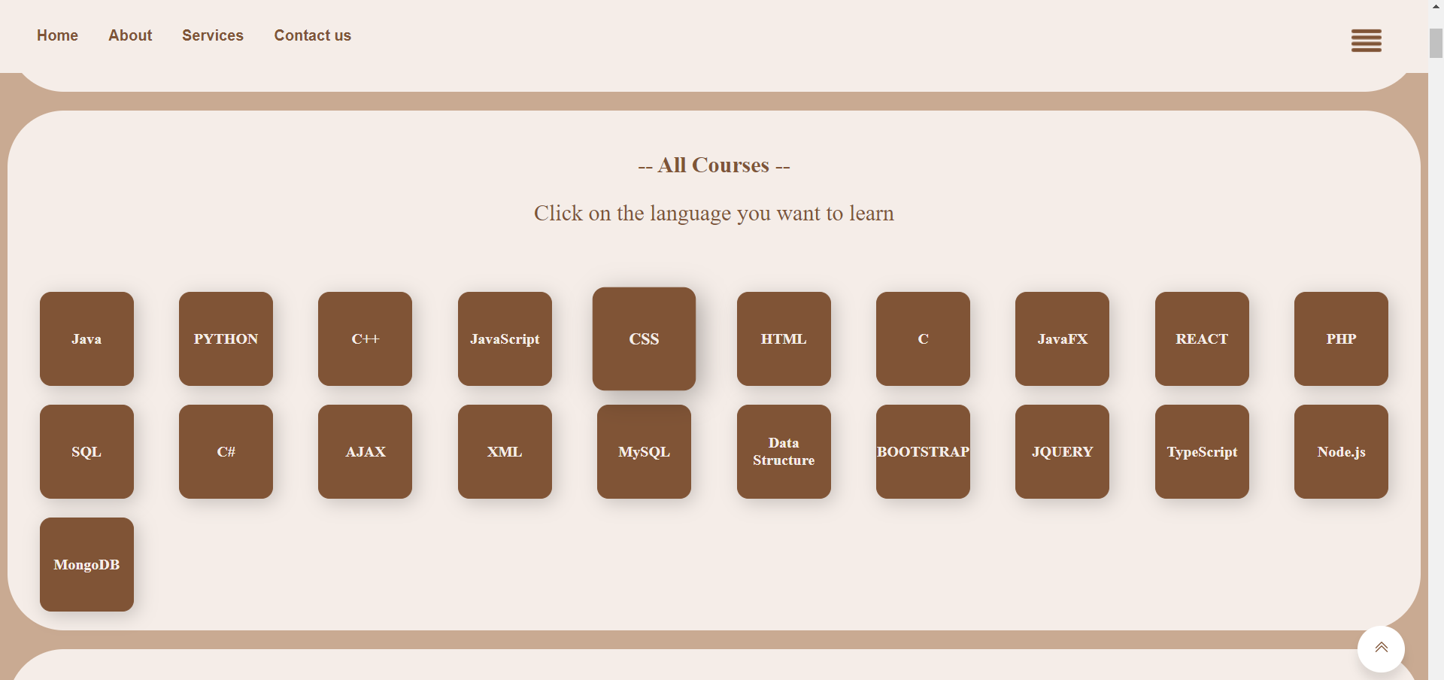



This section contains all the languages ​​that have videos attached to them. If you want to learn CSS, click on the button designated for it and it will take you to its section.

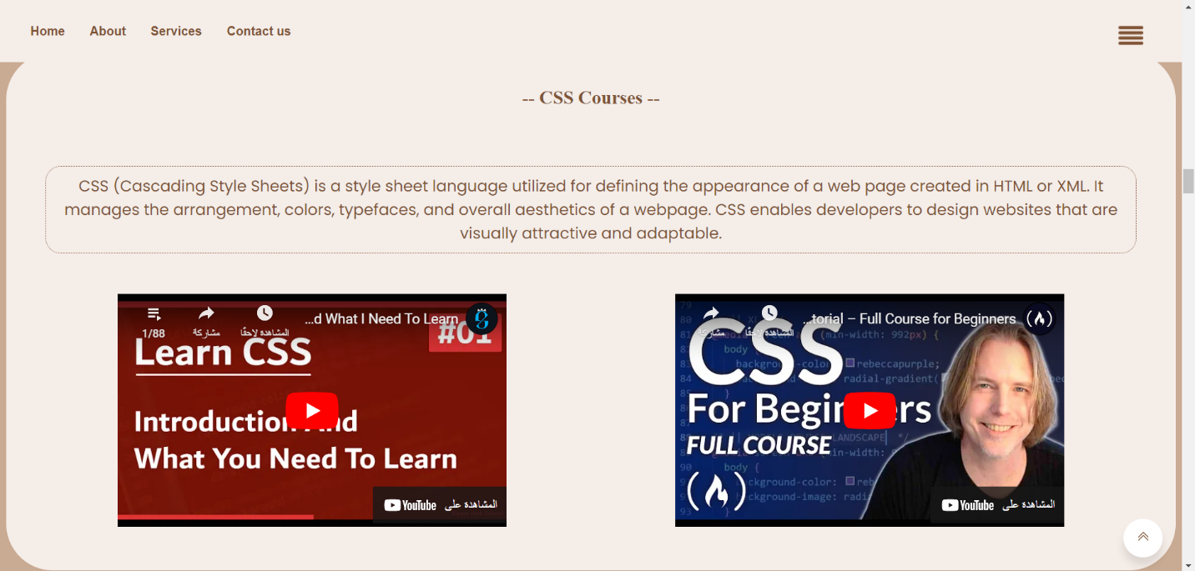

All page:



There is this section through which you can send us what you need by clicking on Contact us and it will take you to the Contact section on the home page.





We notice in the navigation bar the presence of several buttons, the home button takes us to the home page and the rest of the buttons are as I explained above

As for this button when you press it, the following appears:

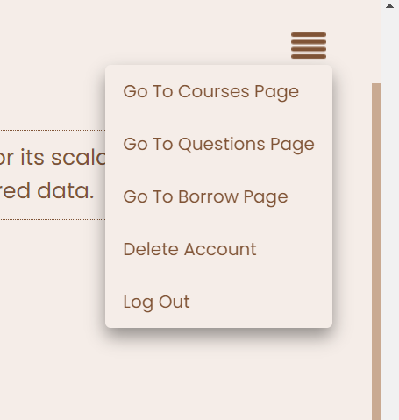

* Go To Courses Page

🡪 Through it, you will be transferred to the courses page.

* Go To Question Page

🡪 Through it, you will be transferred to the Question page.

* Go To Borrow Page

🡪 Through it, you will be transferred to the Question page.

* Delete Account

🡪 When you click on it, the account will be deleted.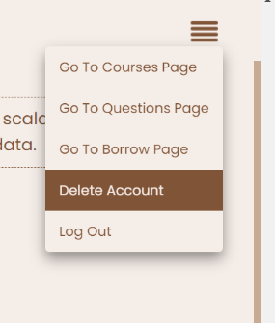

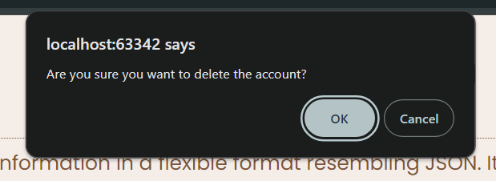



If you click on ok the account deleted then move to login page.

* Log Out

🡪 When you click on it, you will be logged out and redirected to the login page.

--------------------------------------------------------------------------------------------------

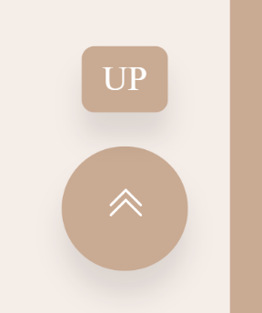

When you click on up button,

takes you back to the beginning of the page.



Borrow page: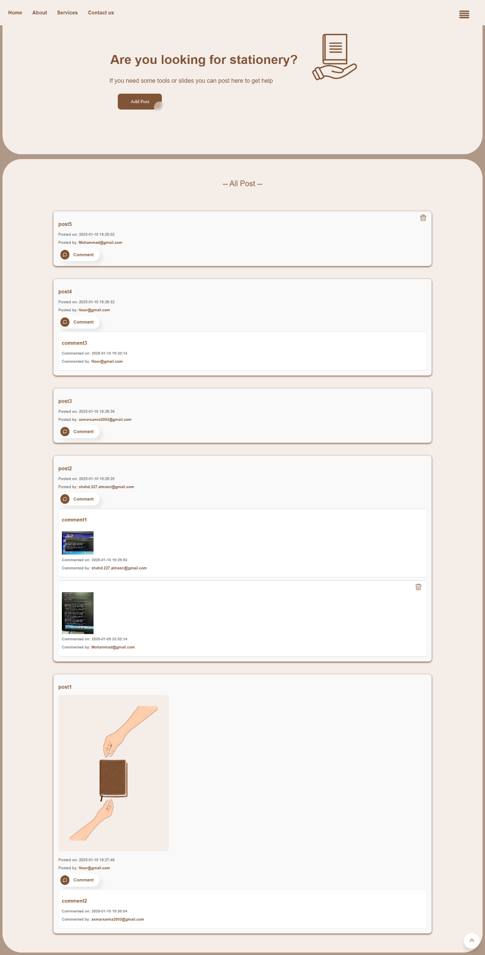

First, we dedicate this page to publishing any slides or study supplies you need.

To publish your own post, you must click on the Add Post button.

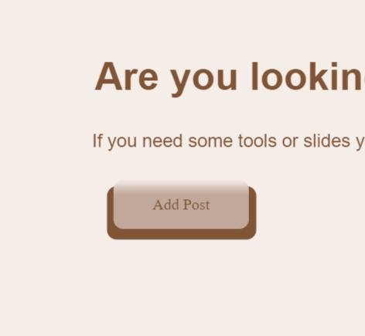



This screen will appear.

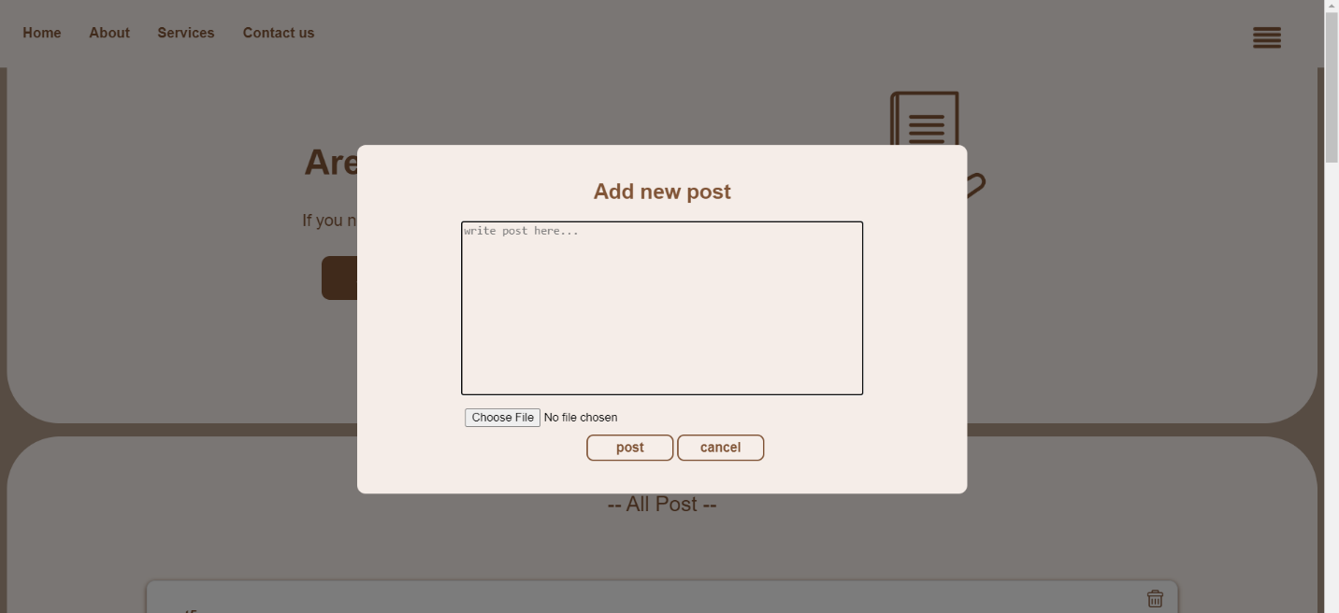

Here you can attach whatever you want and if you want you can attach a picture too.

For example, I will post about (Does anyone have web slides?) and attach a picture

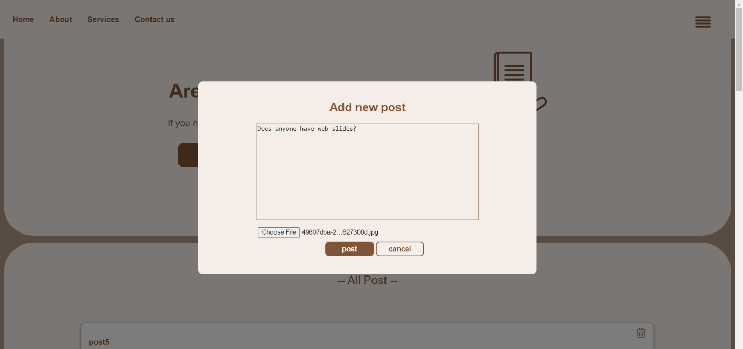

This is the result

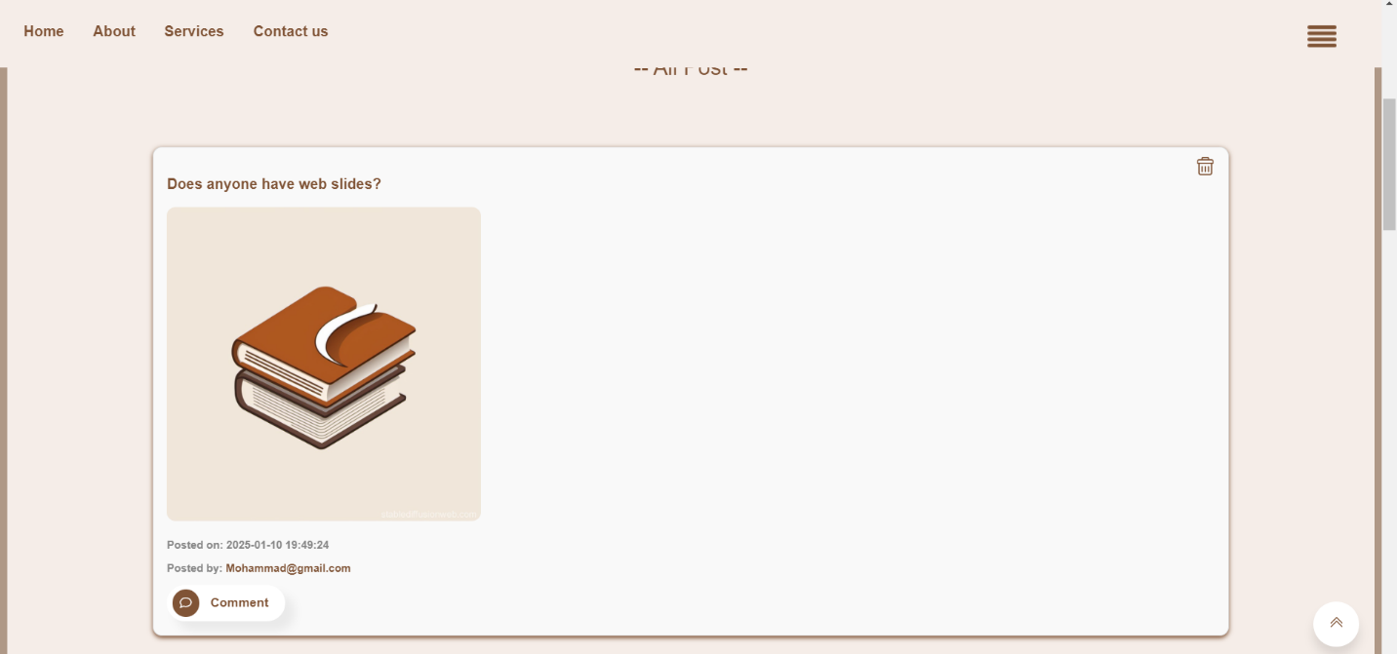

If we notice there is a comment button, when you click on it, your comment will be displayed and you can attach a picture or file.

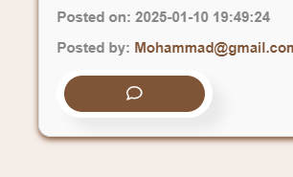

I will post a comment like yes I have (but I will post it from another account)

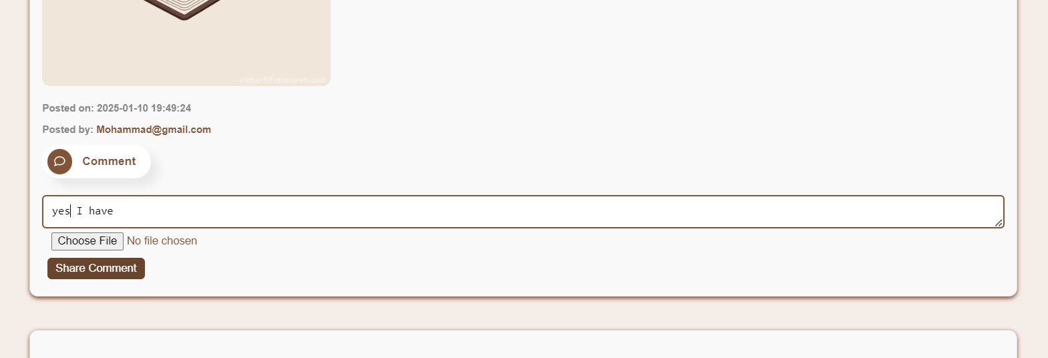

The result

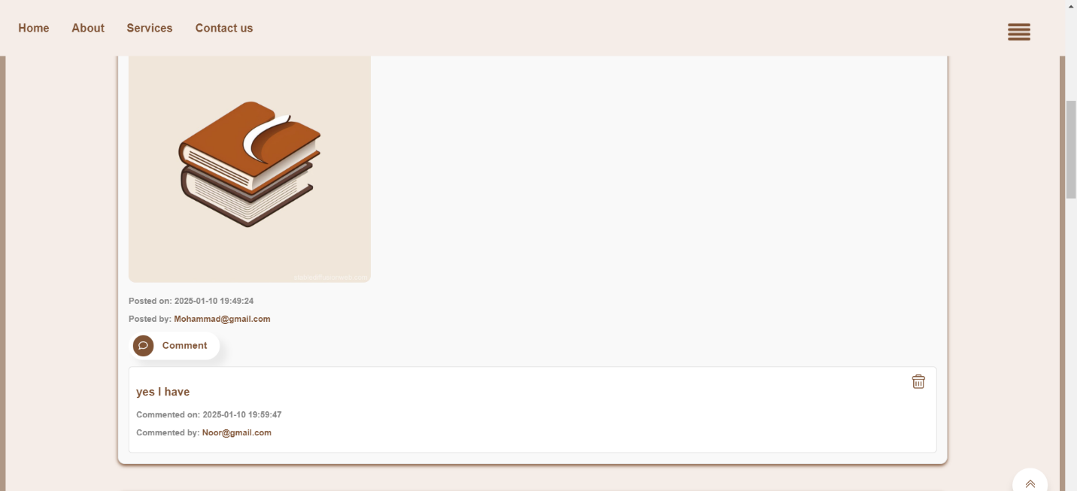



If the owner of the post wants to communicate with the person who commented, all he has to do is click on the commenter’s email and the email interface will appear for him to send whatever he wants.

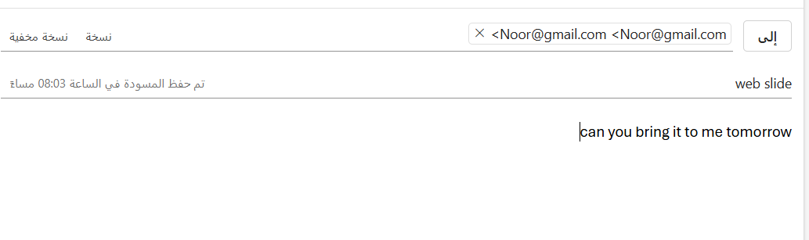

If a person wants to delete his comment or post, he can click on the trash can button and it will be deleted.

But now I am the user of the account Mohammad@gmail.com, as we notice, I cannot delete the comment related to the owner of the email Noor@gmail.com, so only the owner of the post and comment can delete it.

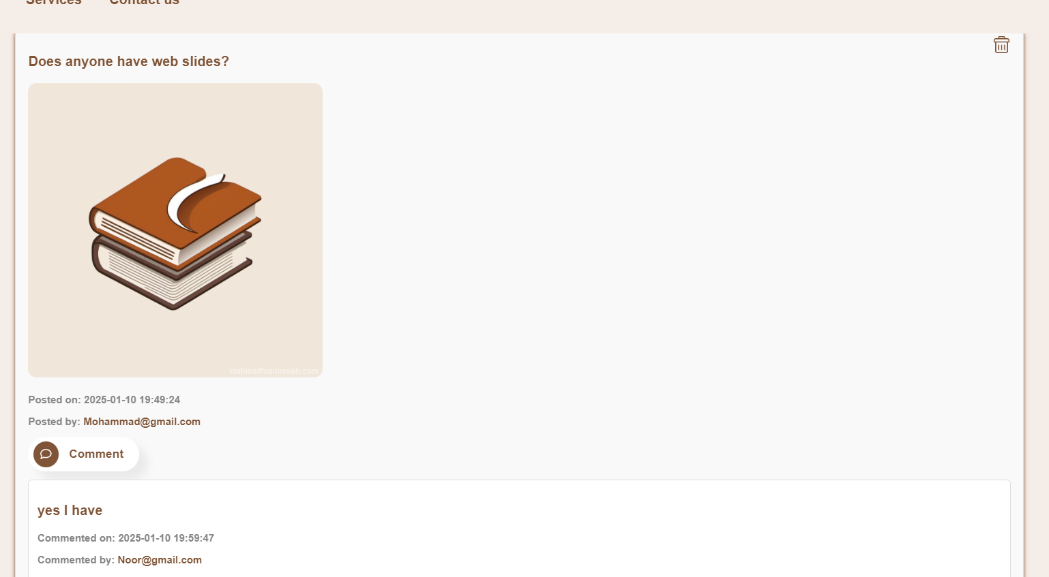



We have two admins with email addresses asmarsamia2003@gmail.com, shahd.227.almasri@gmail.com who can delete any post or comment even if they are not the owners of these posts or comments.

I will log in with the account shahd.227.almasri@gmail.com and show you how the delete buttons work.

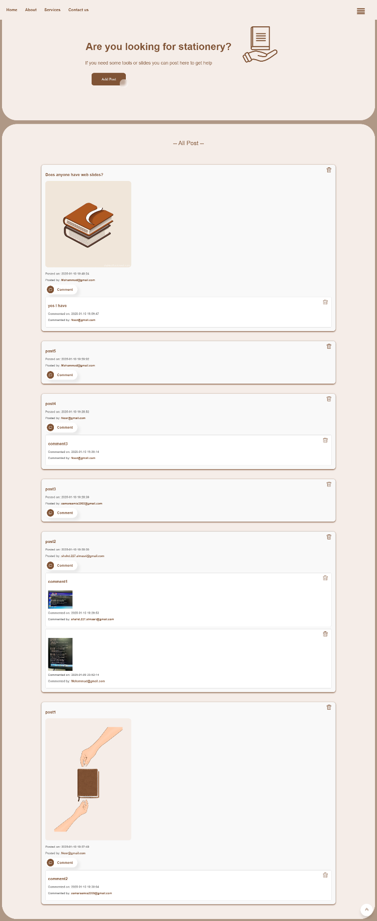



This an example to delete the post with content

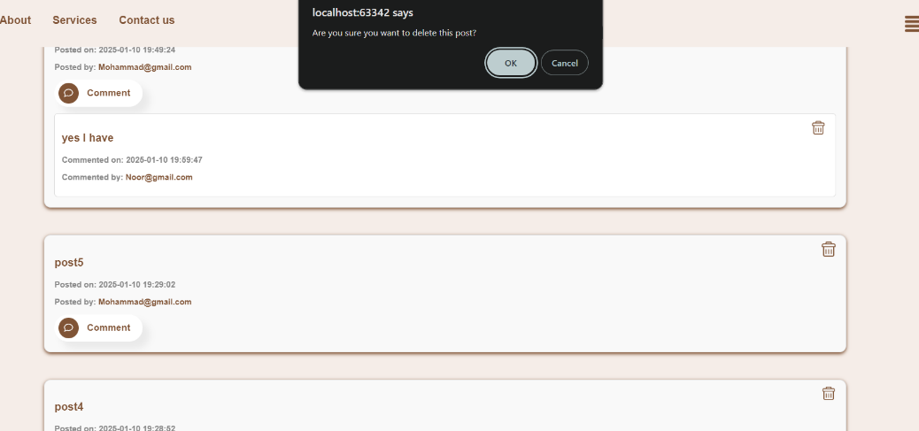



The result it successfully deleted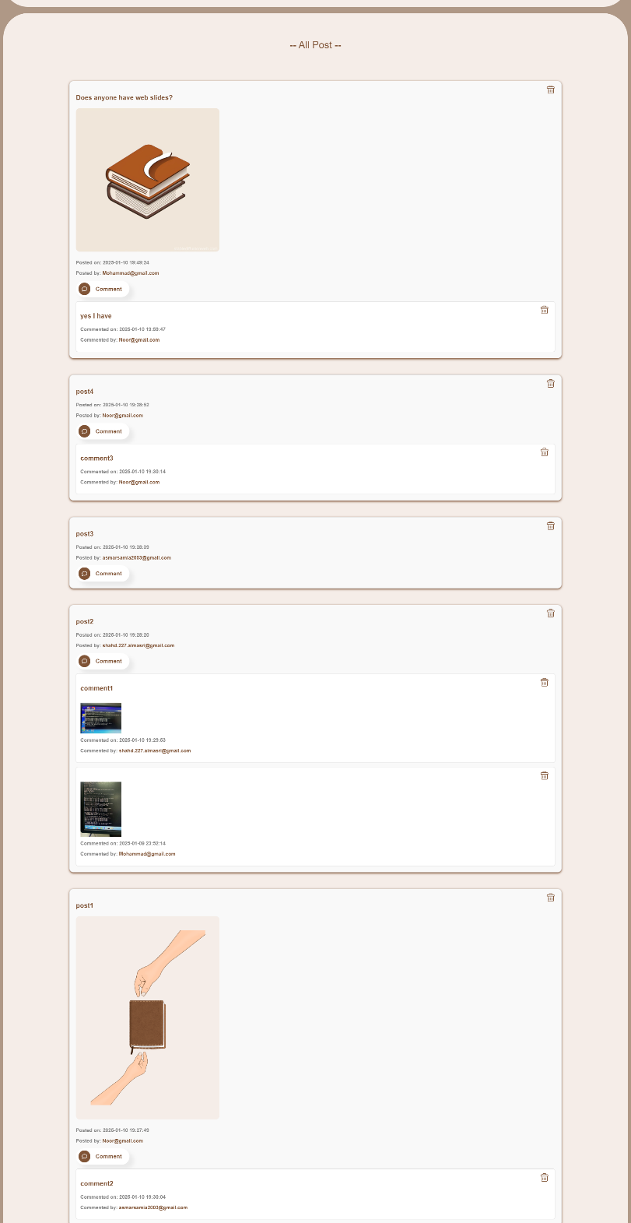

For example, if you want to publish a post and click on the cancel button, when you click on the add post again, what you entered previously will be emptied.

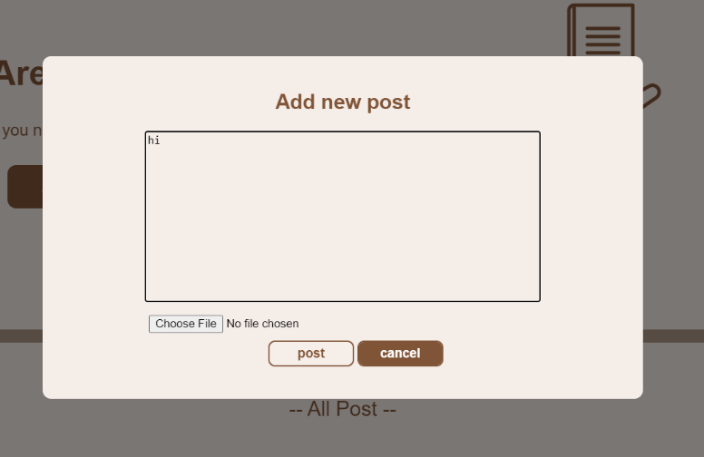

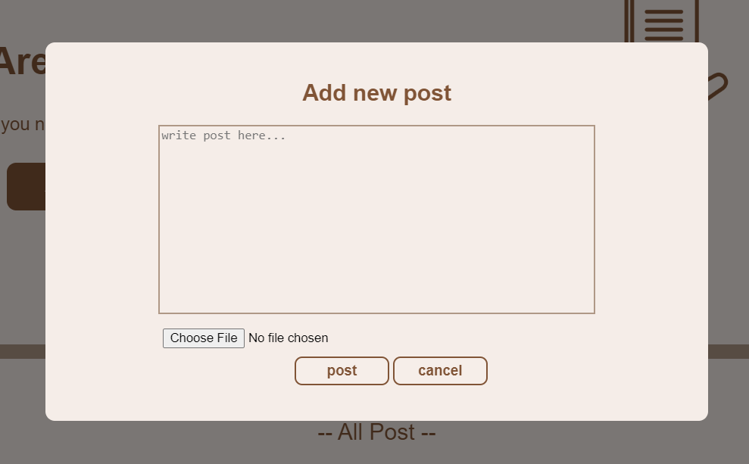

If you want to publish a photo without written content, you will not be able to and this message will appear.

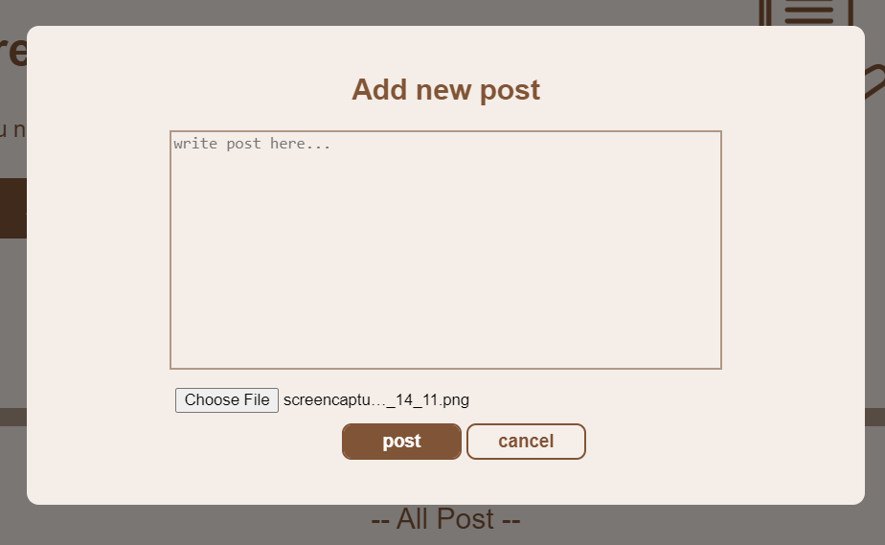



The result

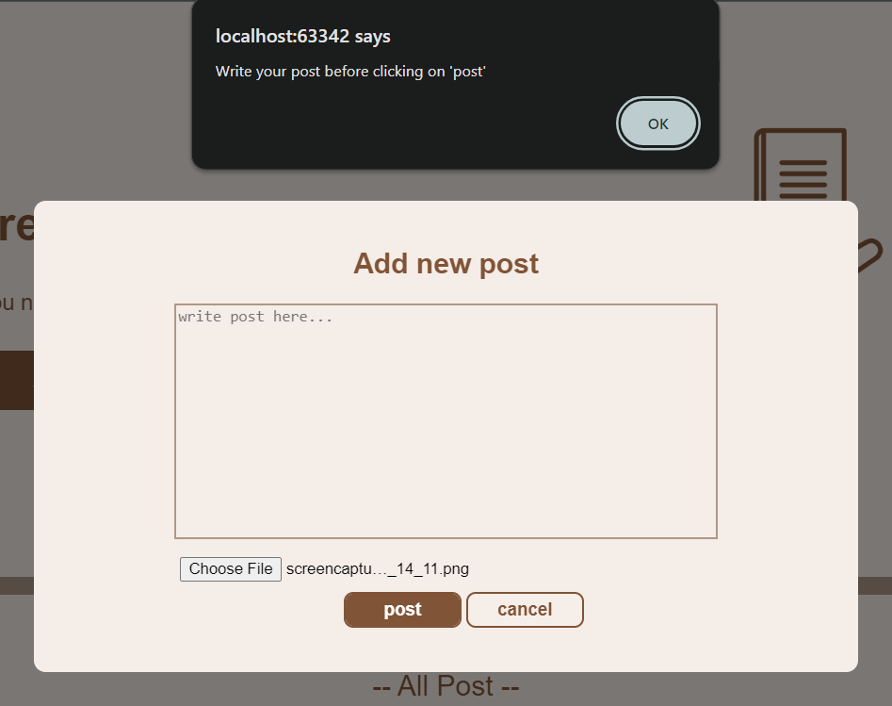

Questions Page : 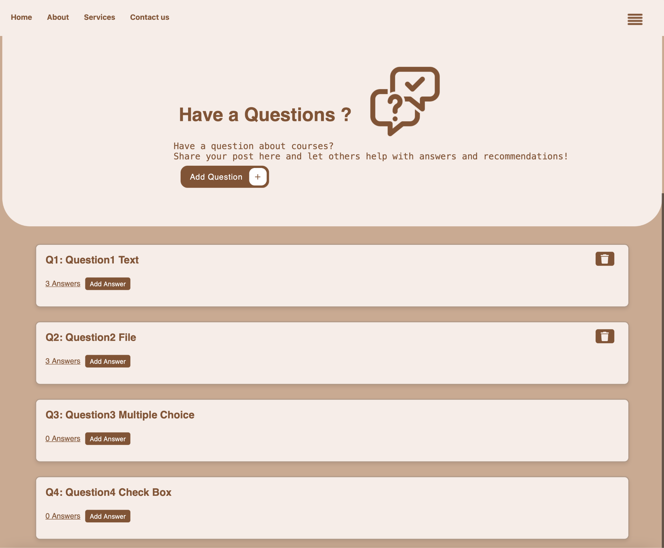

In this page if you need to ask a question for example for courses , publish your question in this page .

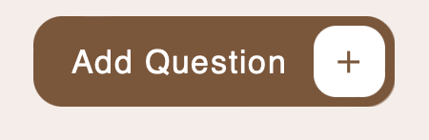

if we click this button this screen will appear :

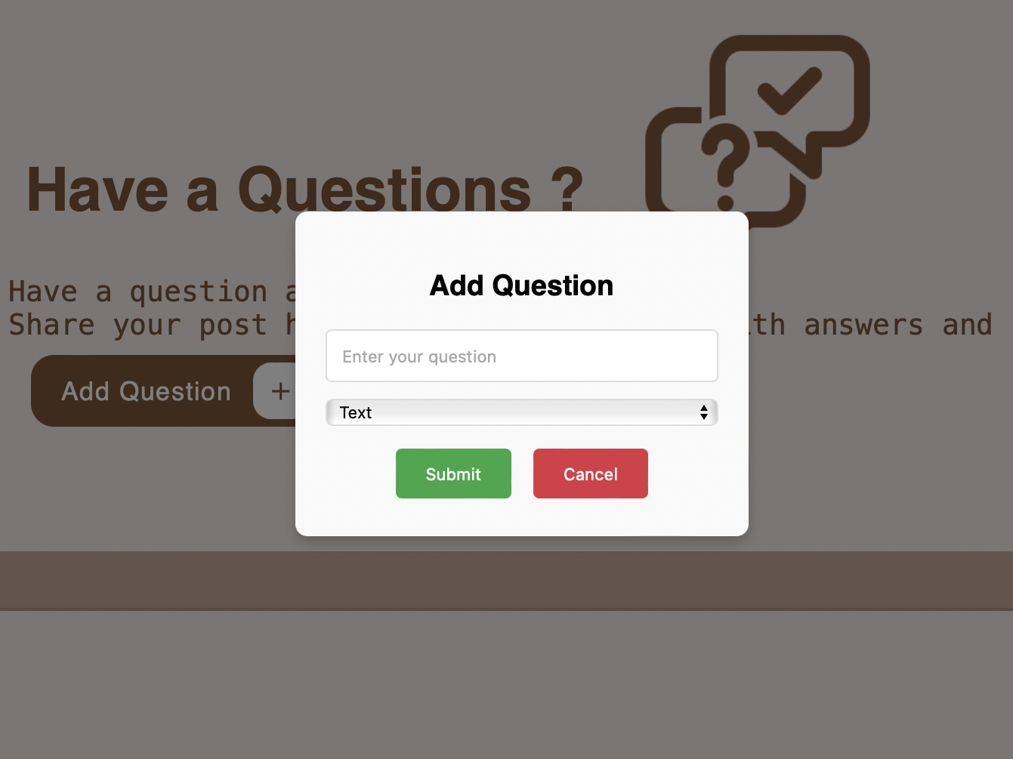

Then you can enter your question and select the type of your question (Text , File , multiple-choice , check box )

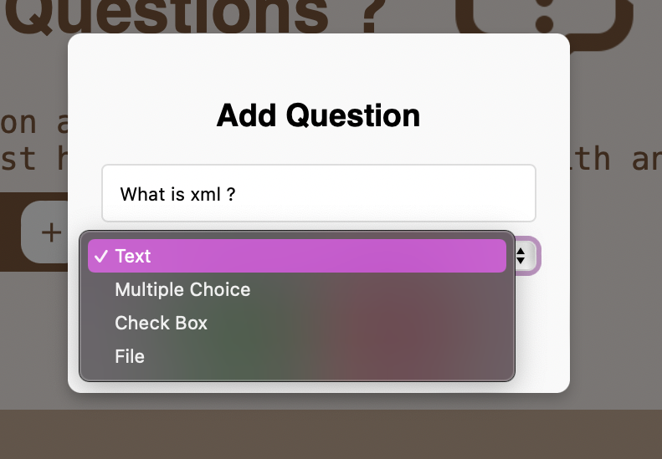

Then when click submit button :

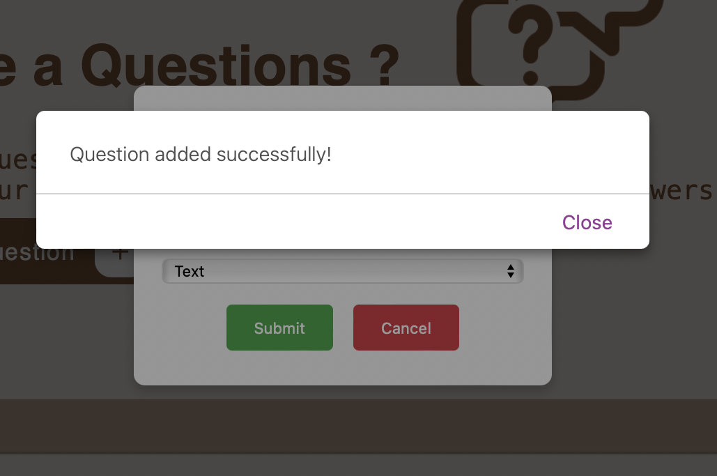

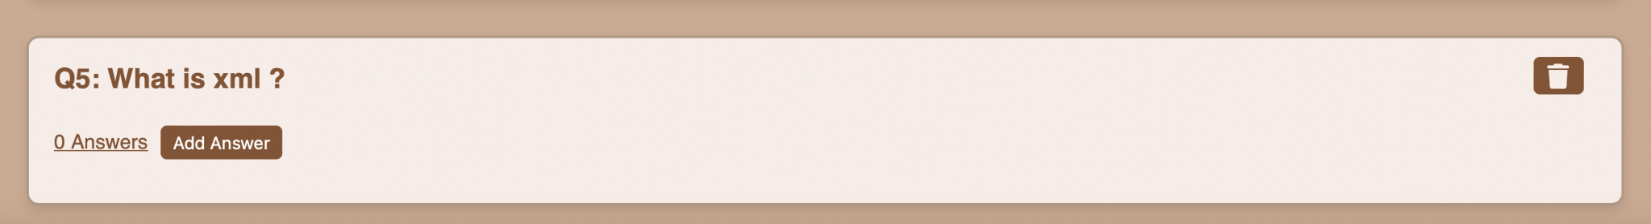

When click the Add Answer button you can add the answer of this questions :

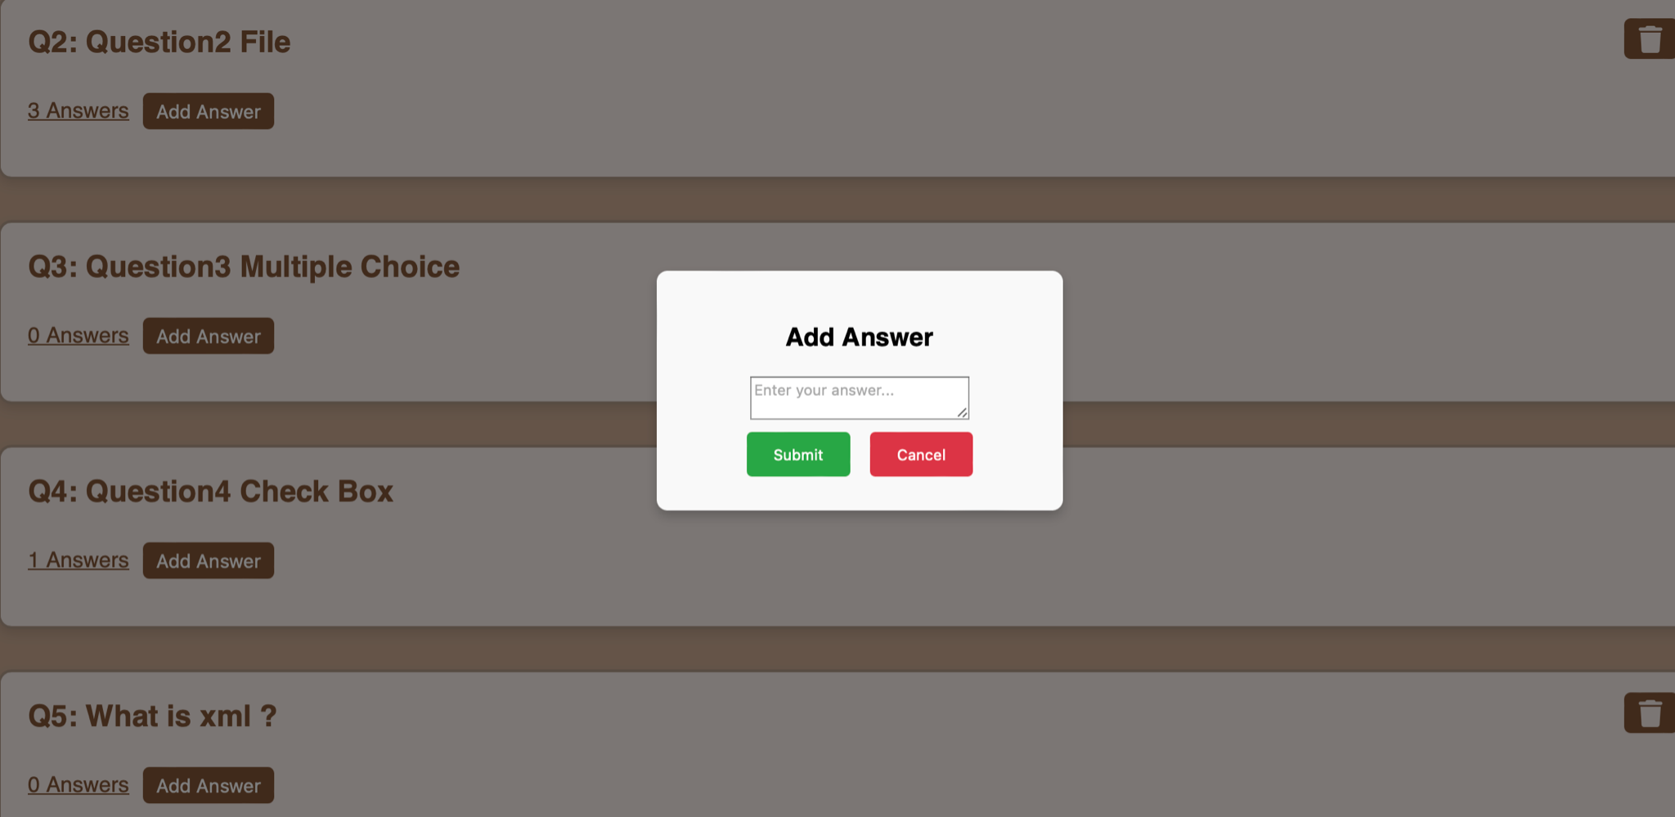

for example , I will to add answer

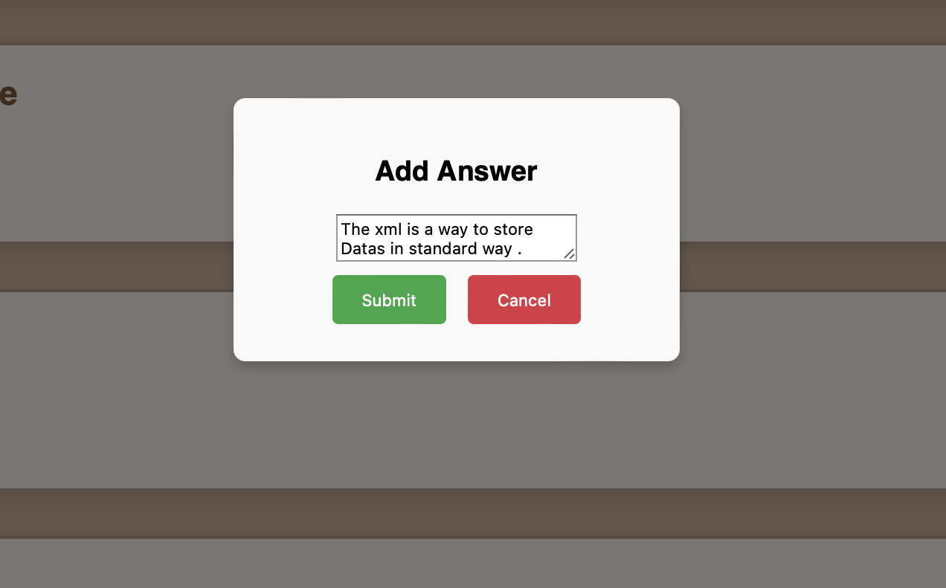

if we click the submit button the answer is publish , if we click the cancel button

then canceled the answer .

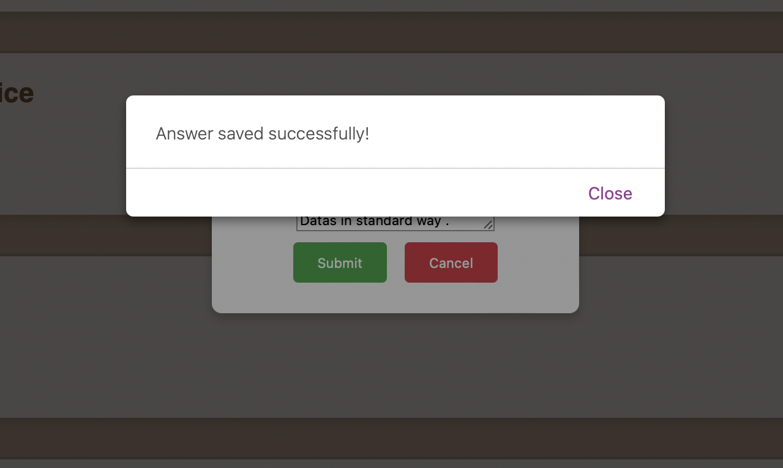

if we click answer , the answers are shown :

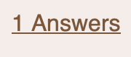

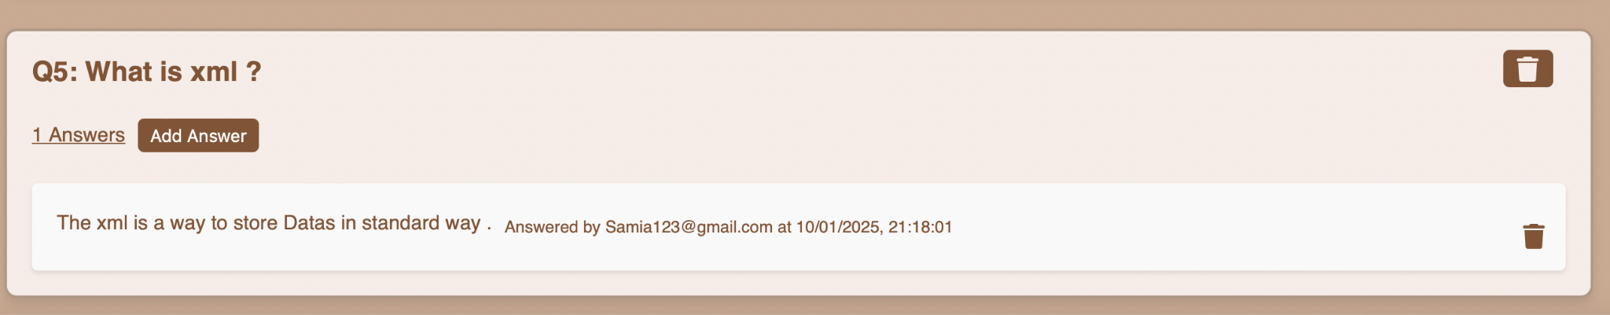

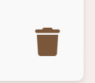

if we delete the answer , click on this button :

The seem for the delete button of Post .

This button is shown only for user that add the answer .

for example this question :

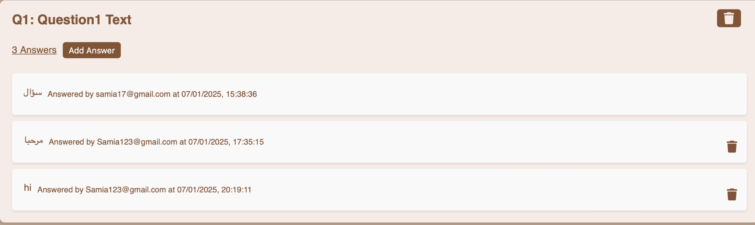

For the first answer the delete button is not shown because the different user is add the answer .

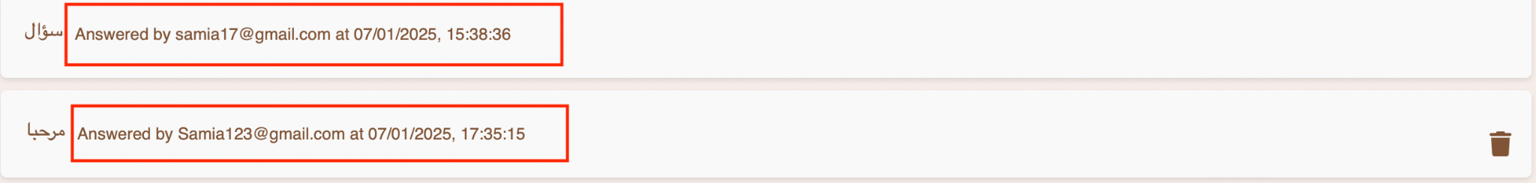

Now , I will try to delete answer ( hi )

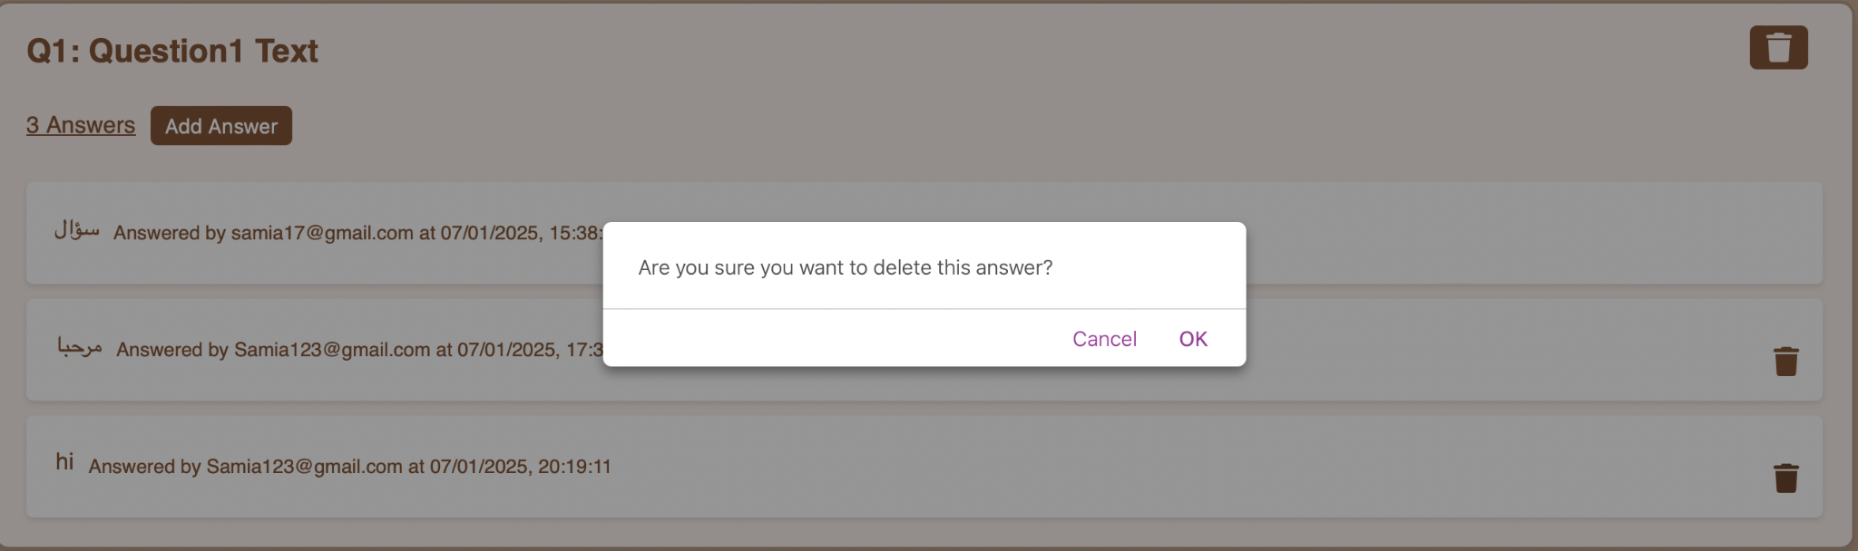

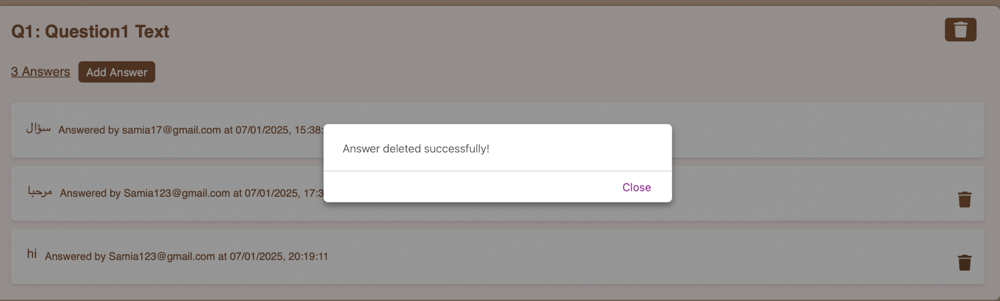

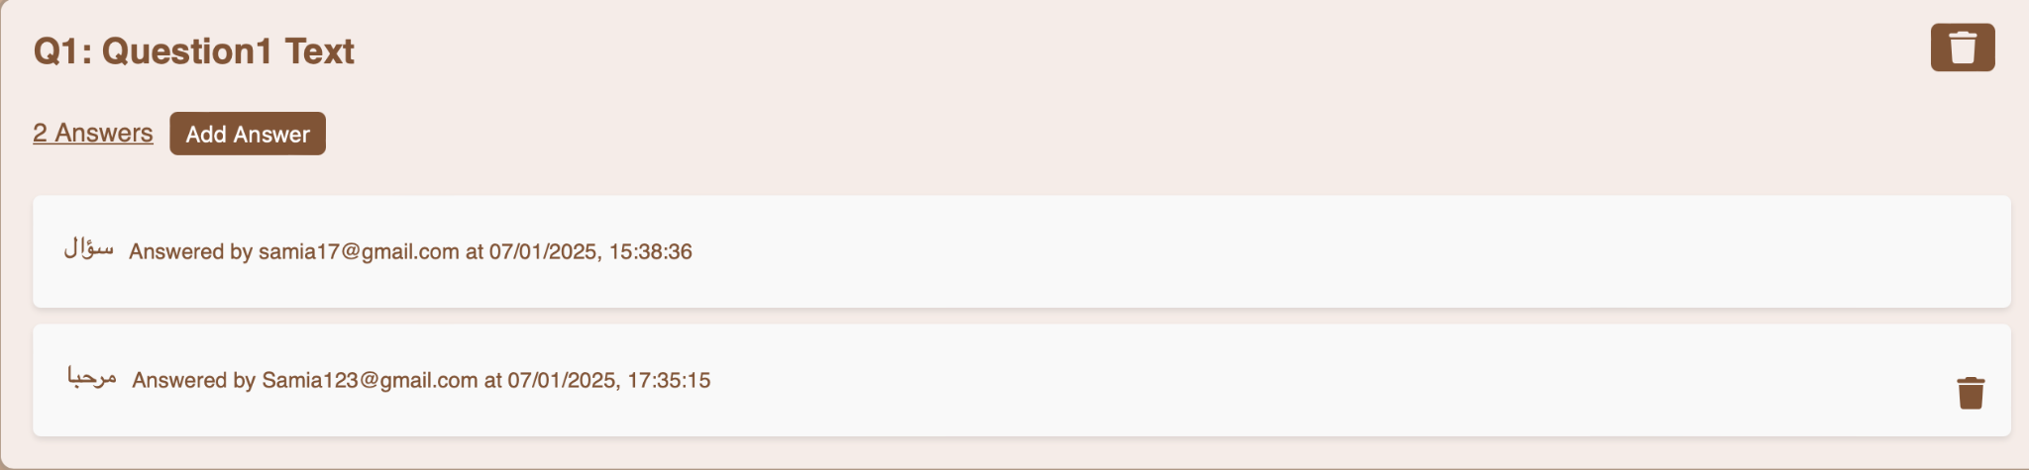

The next type of answer is file :

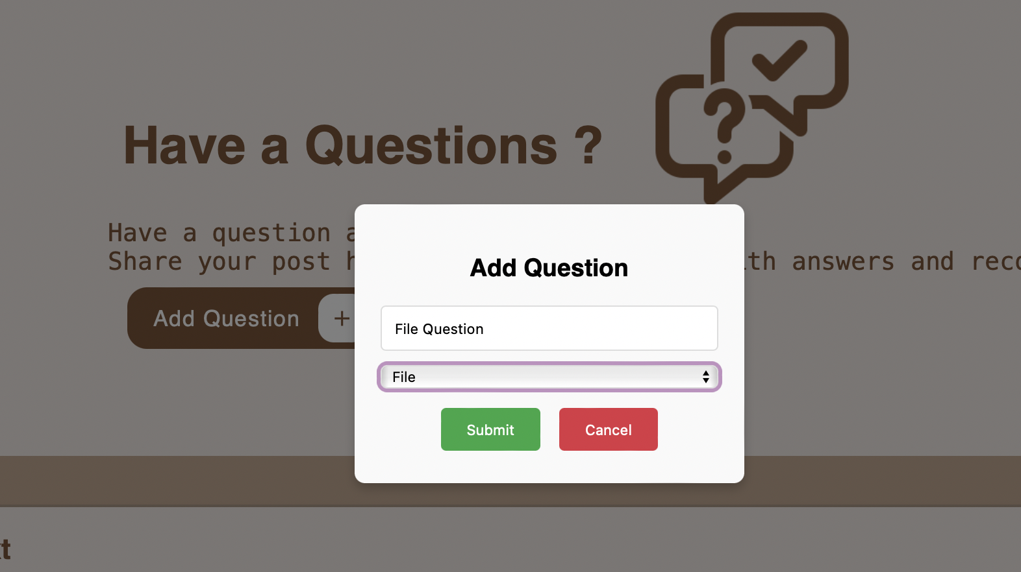

Now i will try to add file answer :

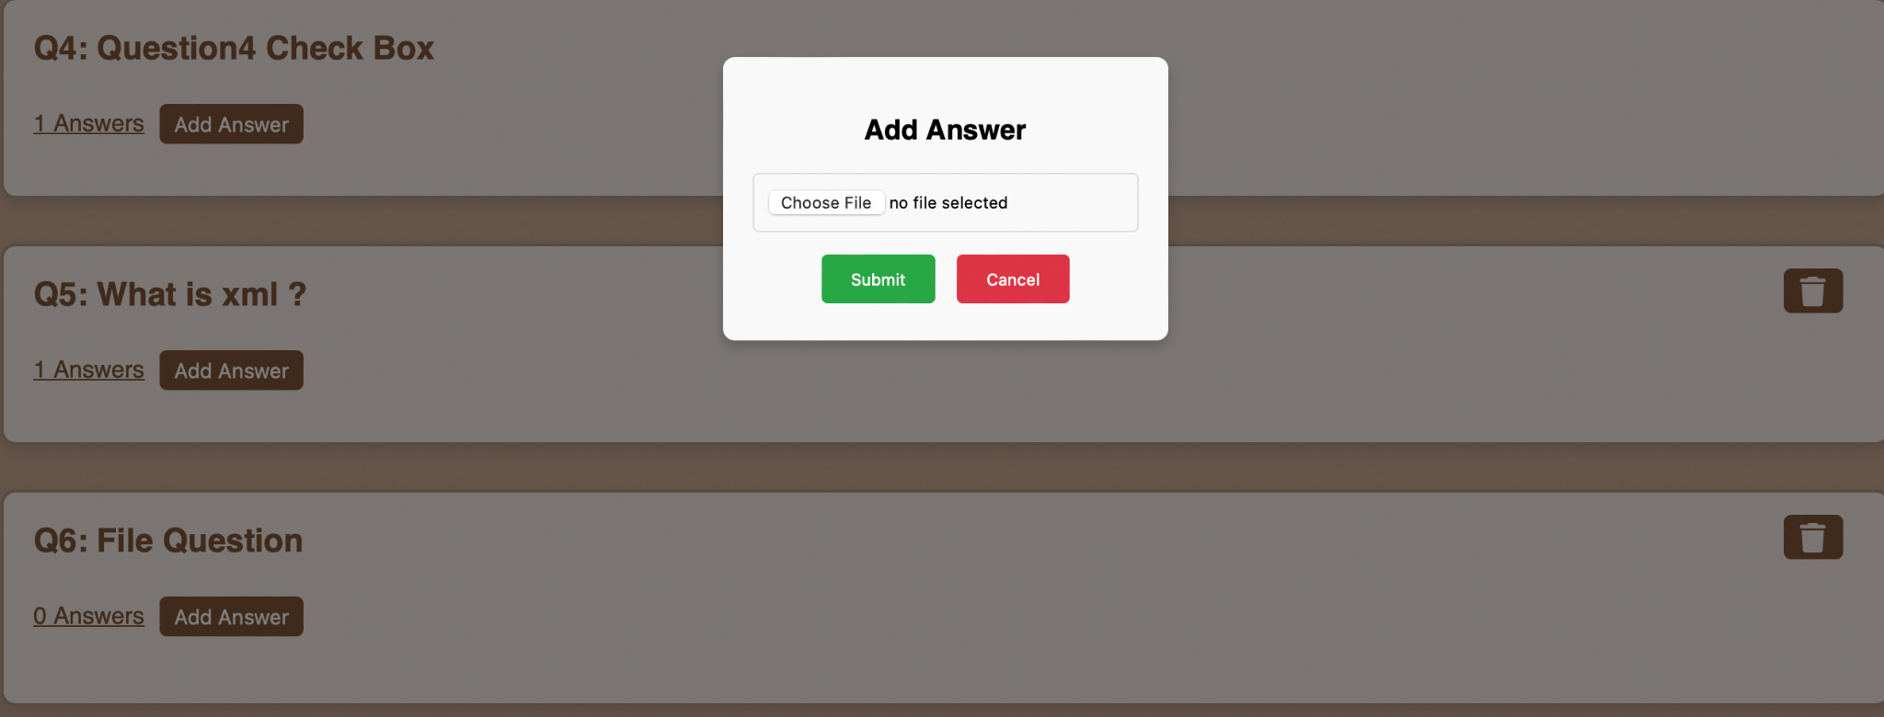

I try to upload for example this file :

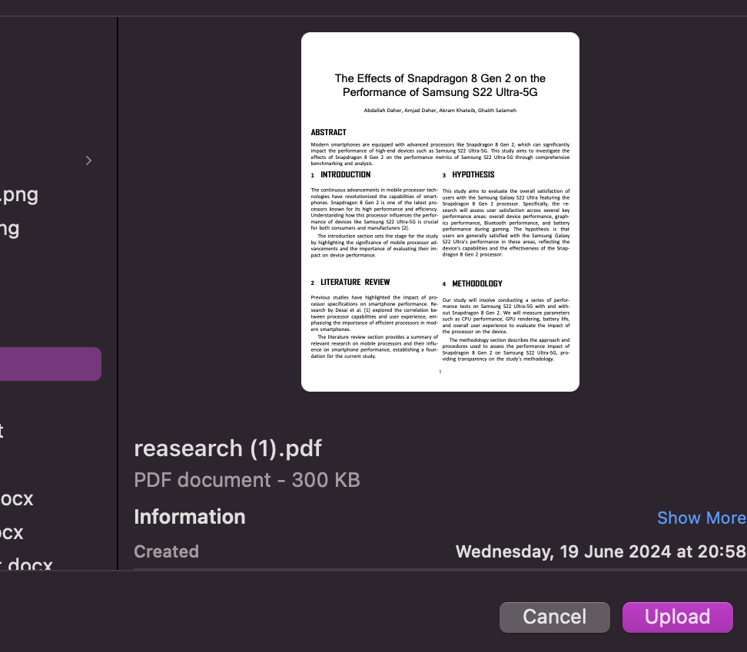

The answer is added :

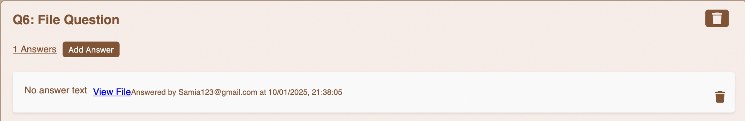

If we like to show the file , just click in View File , The new tab will open :



The result :



and if we like to add image answer the same thing .

Third type of answer is multiple choice :

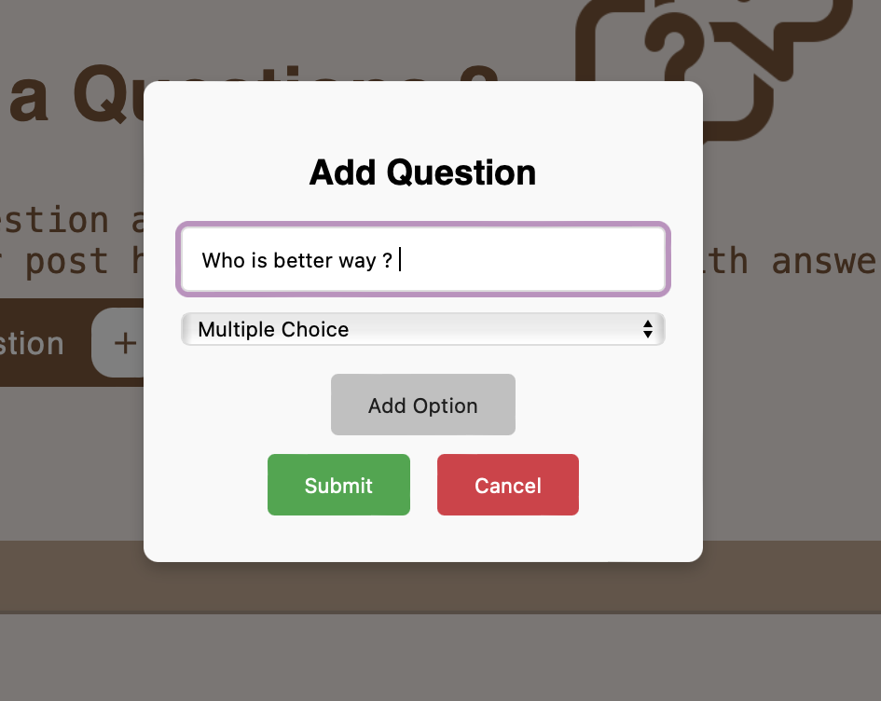

for multiple choice or check box you can add as many options as you want..

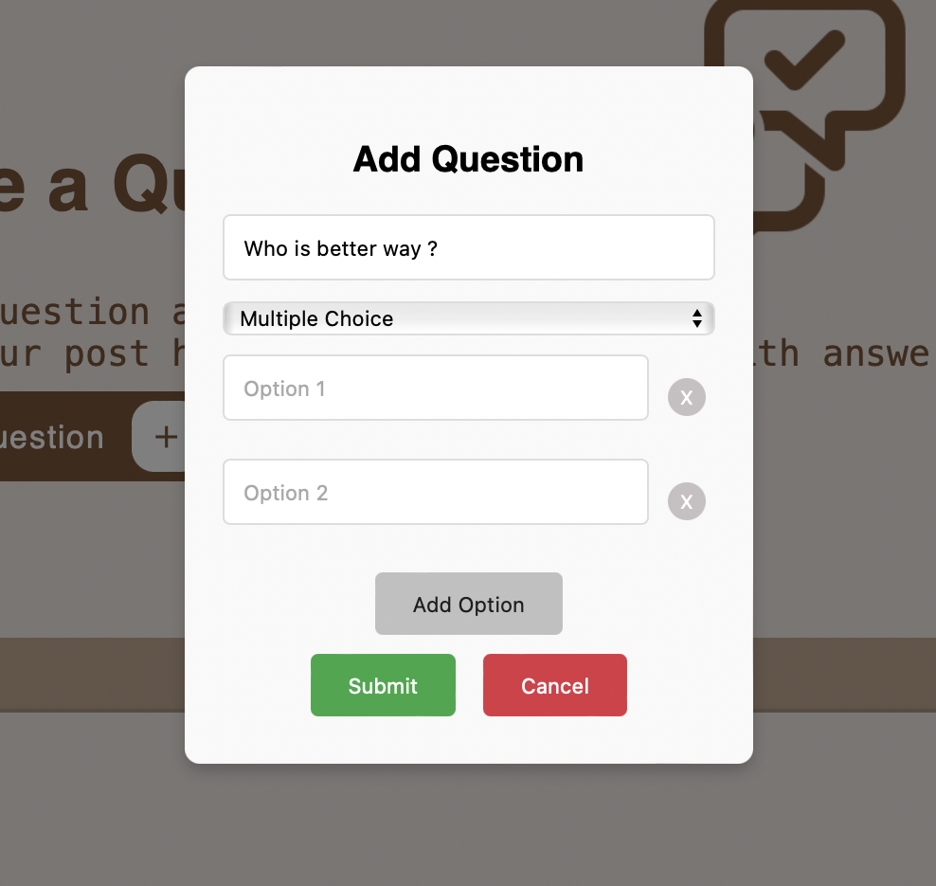

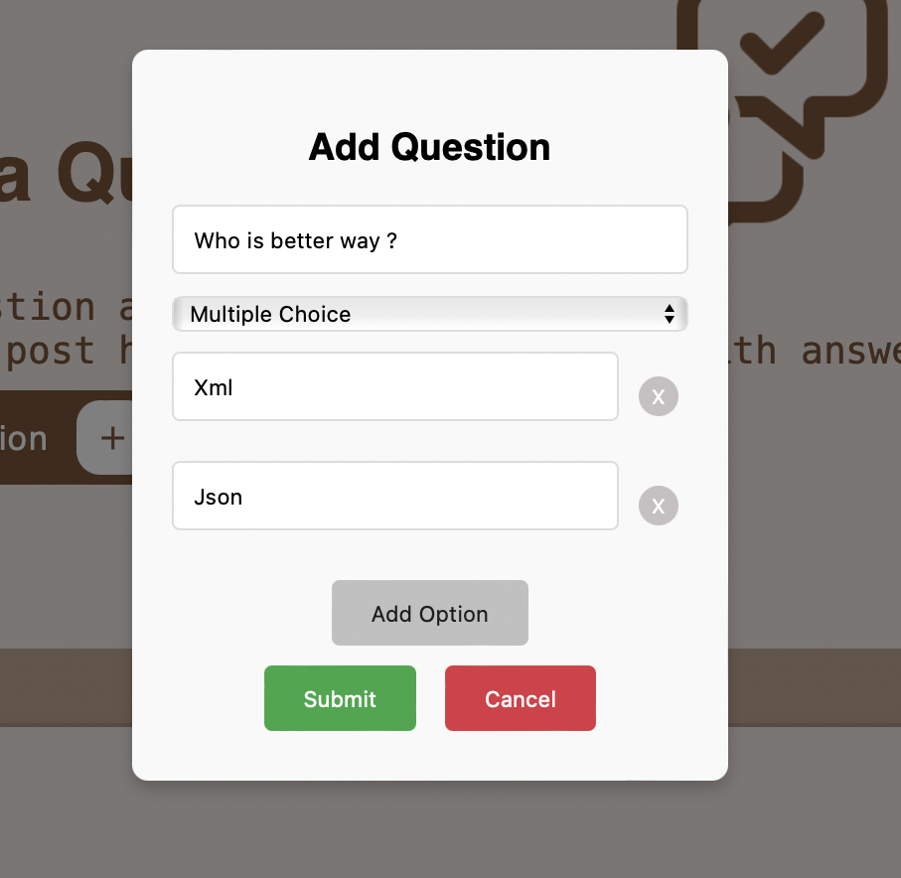

Then click to submit and your question will be added :

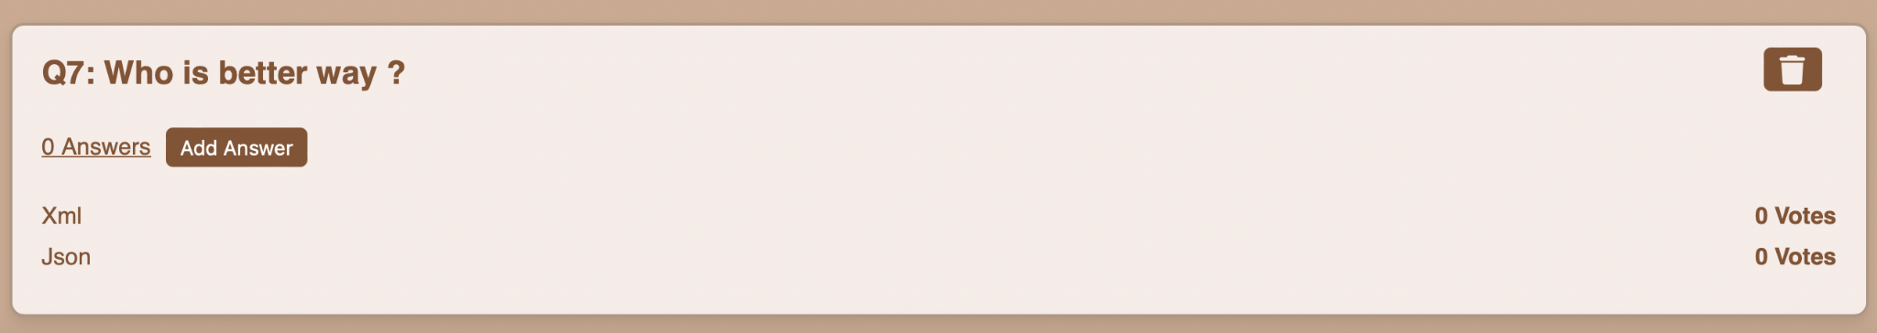

The user can only vote and choose once.

if we click Add Answer :

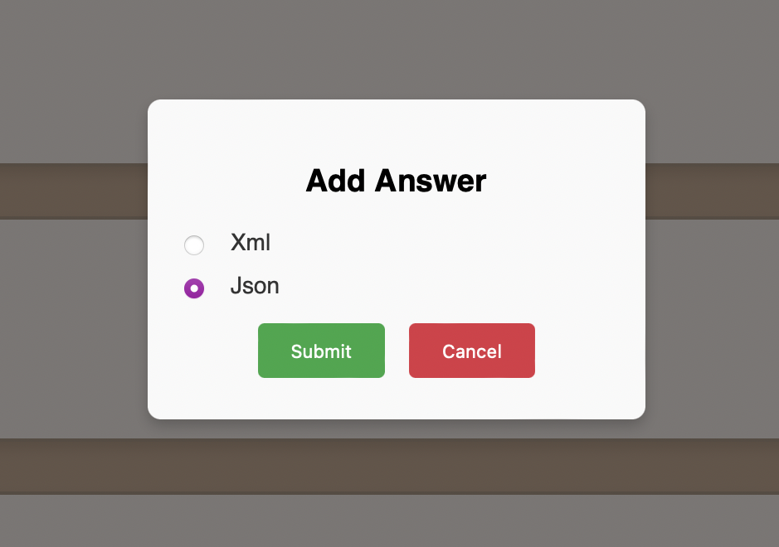

The vote of Json will be increased :

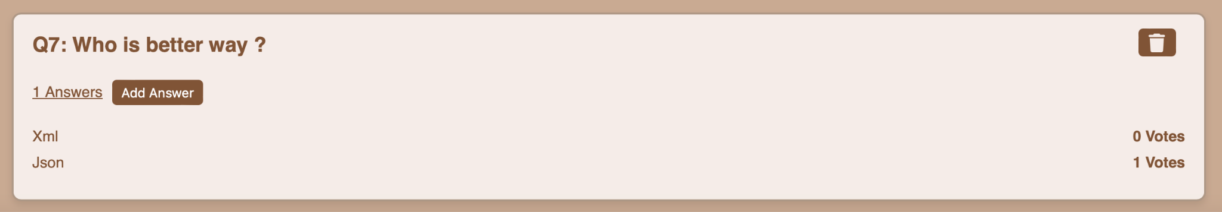

if we try to add vote another time :

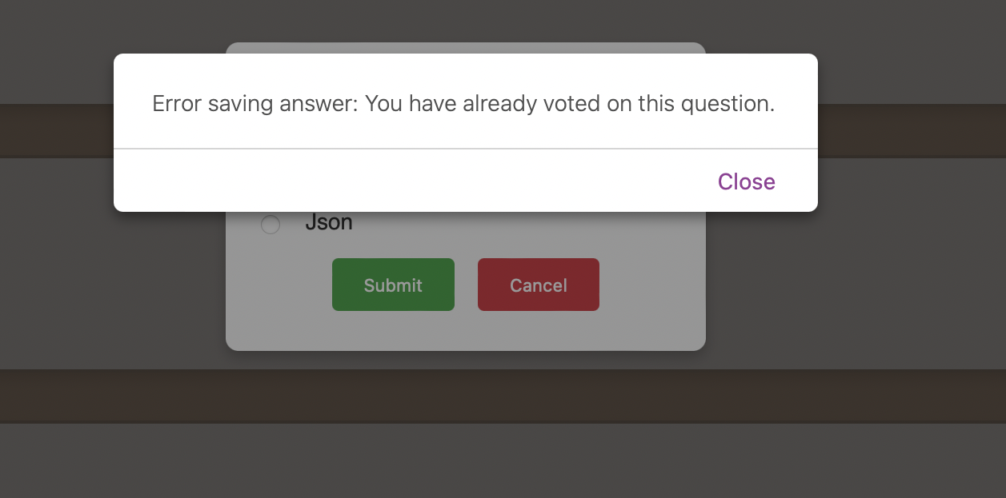

I will try to logout from this account and login from another account then try to vote :

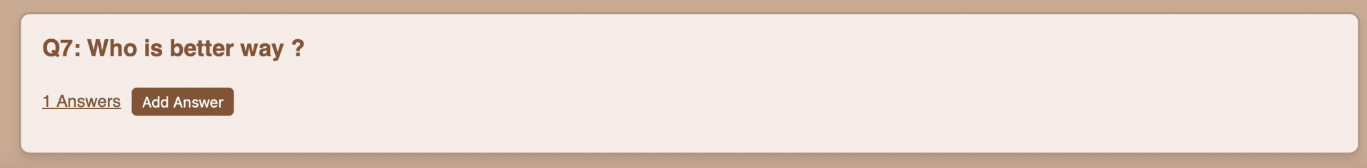

The delete button is hidden because i am login from another account :

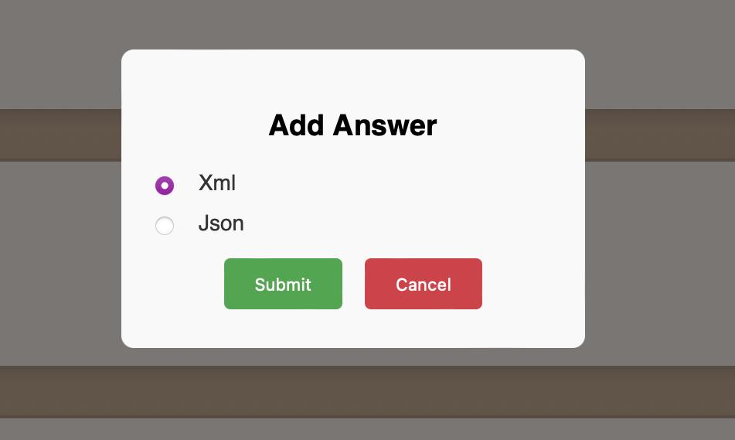

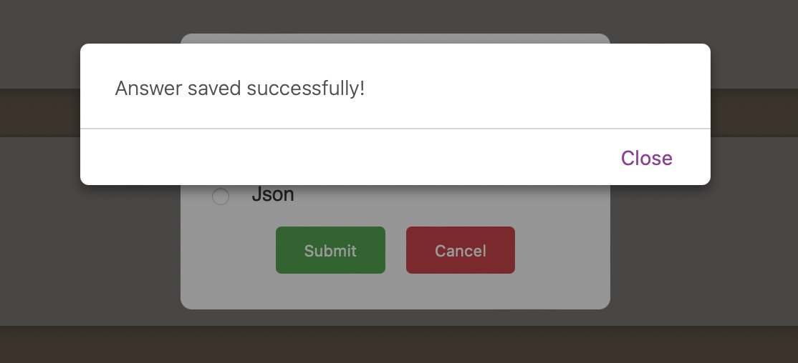

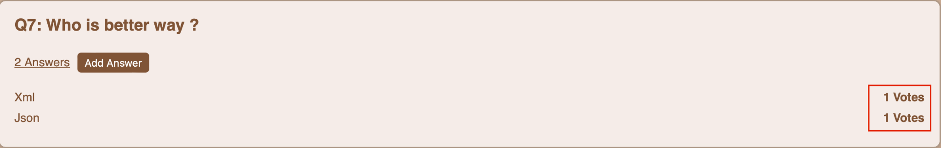

forth type of answer is check box :

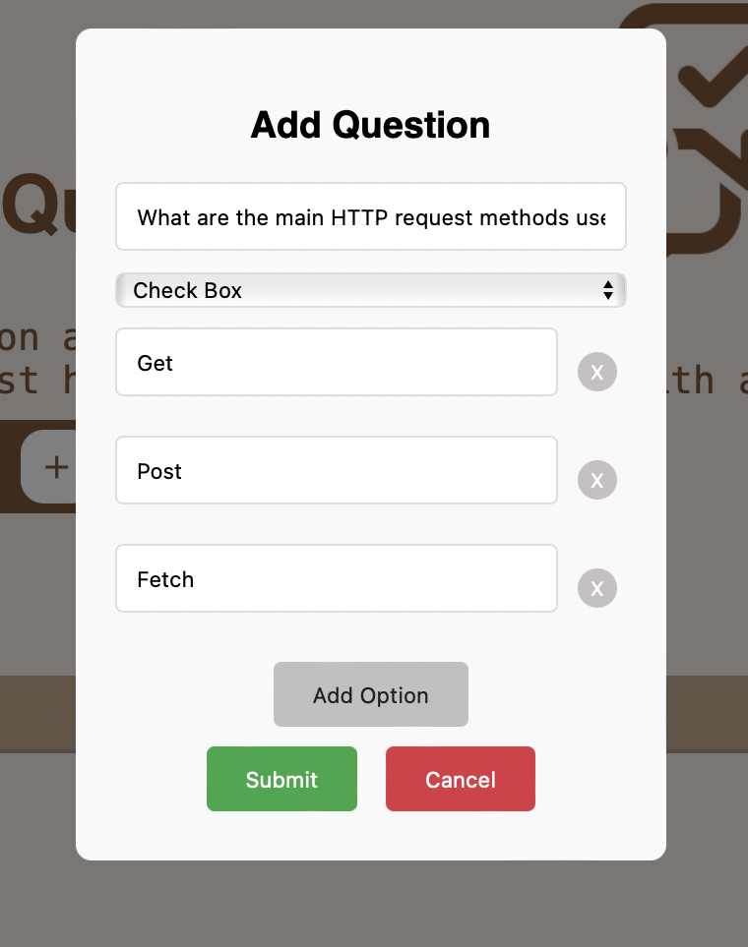

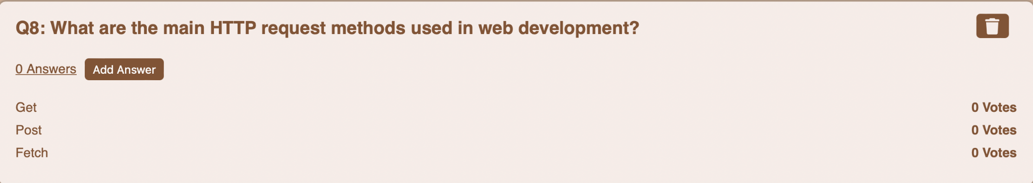

I will try to add answer :

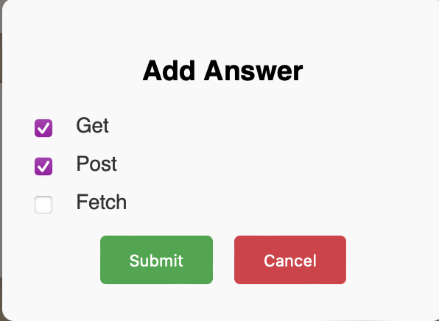

The result :

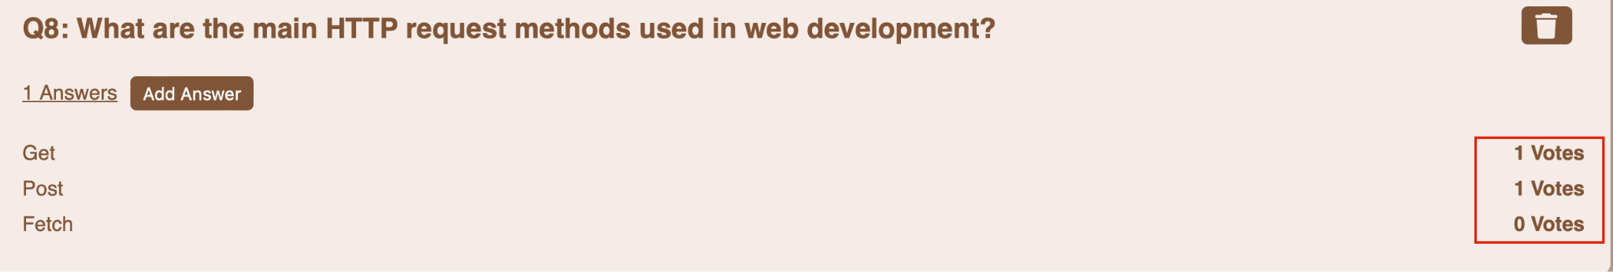

I will try to delete Post :

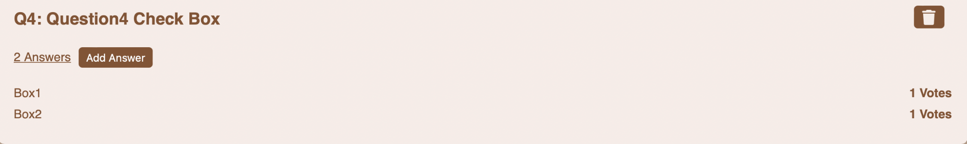

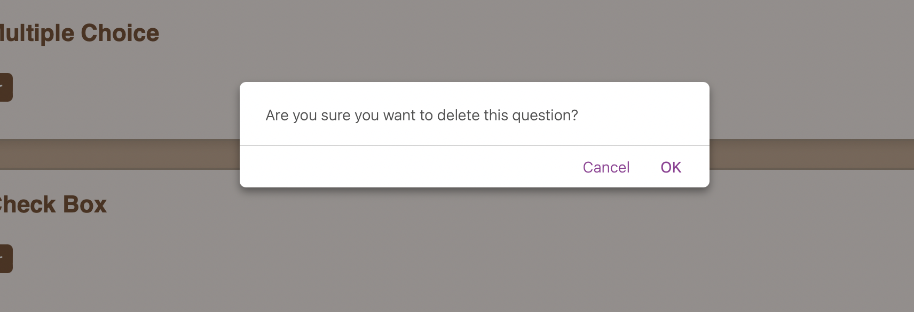

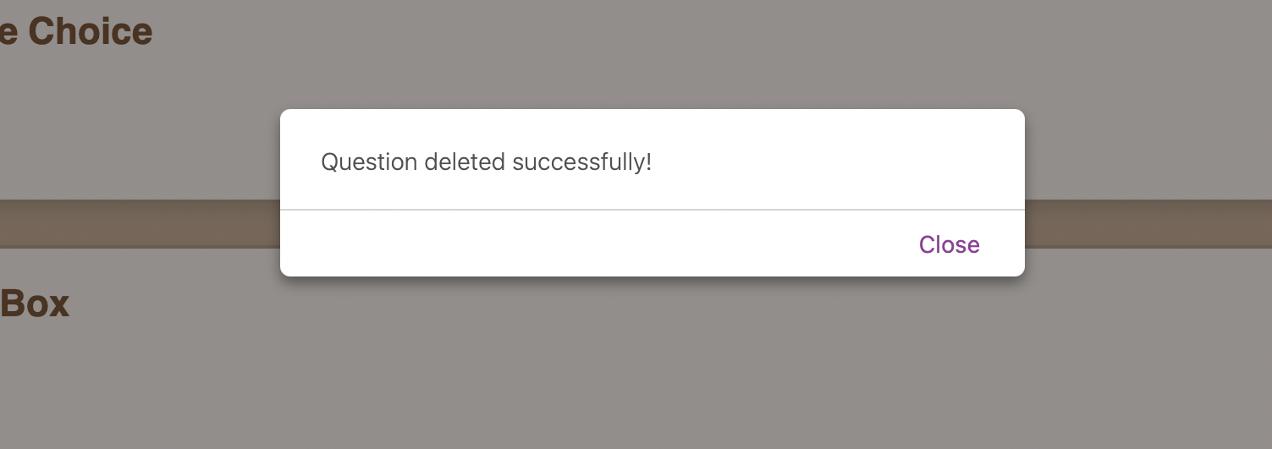

The admins Can delete any question or answer ( for example not suitable answer or question ) :

I am log in now in admin account :

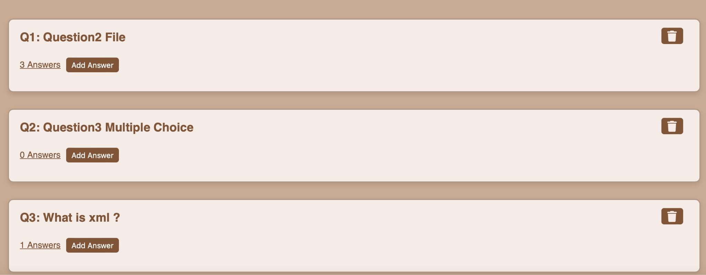

I can delete any question ( for example question 1 ) :

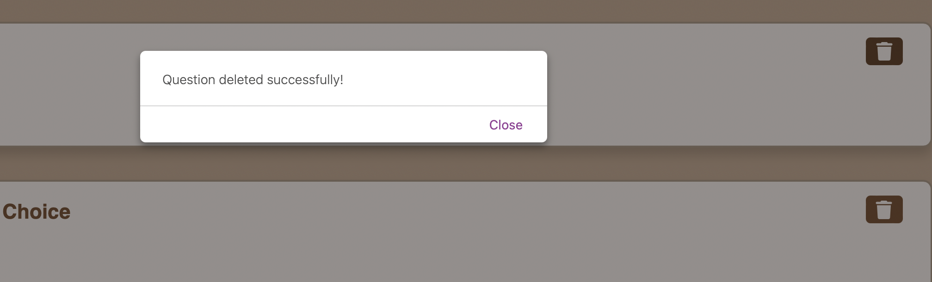

and the same thing for the answer .

conclusion:

In conclusion, this web platform is designed to be a comprehensive solution for students, offering a seamless and interactive experience that enhances their academic journey. From creating and managing accounts to borrowing slides, sharing resources, and fostering collaboration through questions and answers, every feature is tailored to meet the unique needs of students. The integration of services, intuitive navigation, and secure data handling ensures a smooth and reliable user experience.

By providing an organized space for learning, collaboration, and support, this platform not only simplifies access to educational resources but also empowers students to engage, share, and grow together. It’s more than just a website—it’s a community built to inspire and support academic success.

References :

1- lottiefiles <https://lottiefiles.com/>

2- Canvas <https://www.canva.com/>

3- FlatIcon <https://www.flaticon.com/>

4- StorySet <https://storyset.com/>

5- Freepik <https://www.freepik.com/>